**Week 1: OOP**

<https://nus-cs2103-ay2122s1.github.io/website/schedule/week1/topics.html>

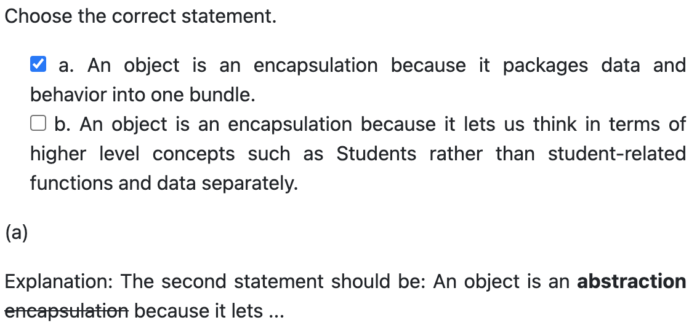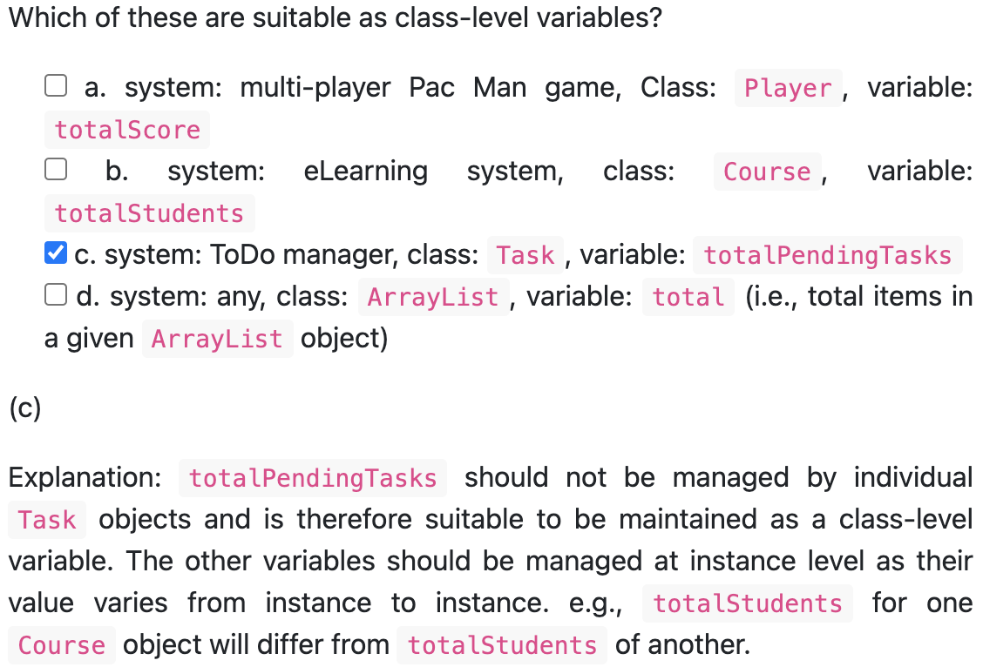

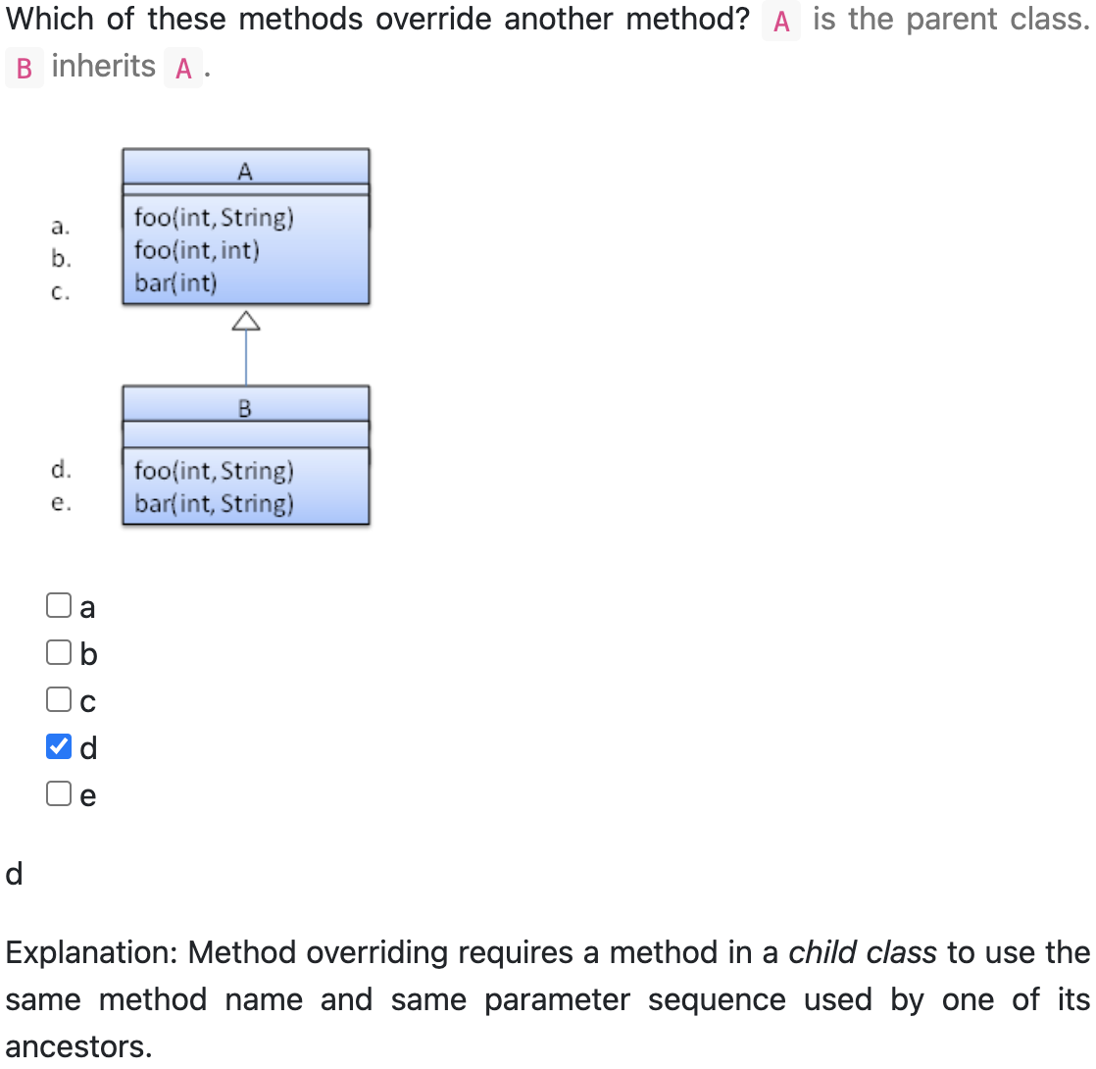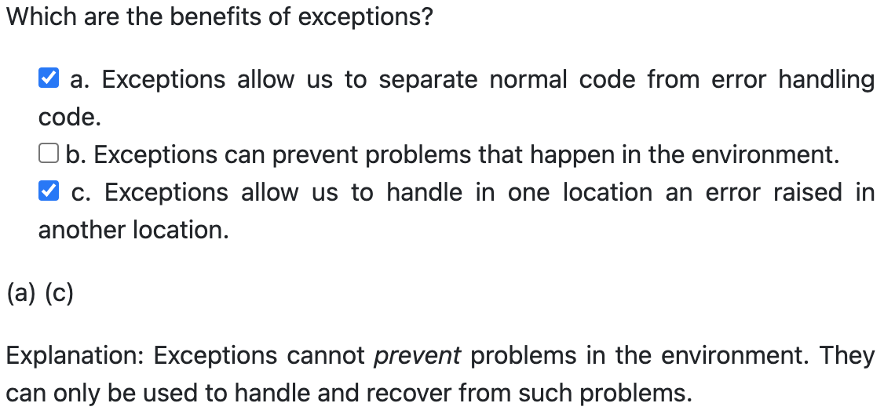

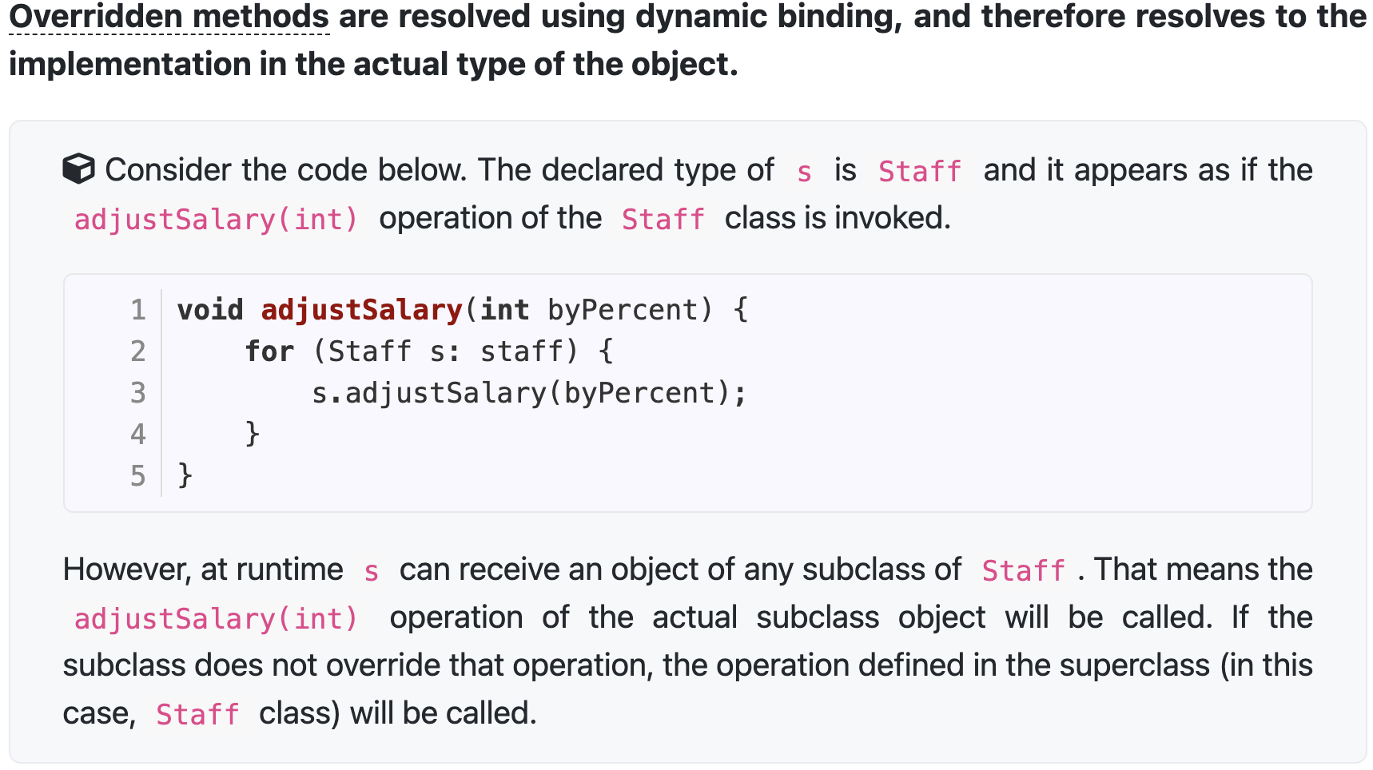

6. Objects interact by sending messages.

8. Packaging is one aspect of encapsulation i.e., An object packages data and related behavior together into one self-contained unit.

10. A class contains instructions for creating a specific kind of objects.

12. **A class-level member can be accessed using the class name, but also using an instance of the class.**

20. Constructors are not members, so they are not inherited by subclasses, but the constructor of the superclass can be invoked from the subclass. (super)

21. In Java, method **overloading** can happen within the same class or among classes in an inheritance hierarchy.

24. A class that has an abstract method becomes an abstract class.

25. In Java, even a class that does not have any abstract methods can be declared as an abstract class.

27. A class implementing an interface results in an **is-a relationship**, just like in class inheritance.

28. Interfaces cannot be instantiated - they can only be implemented by classes.

33. Every instance of a subclass is an instance of the superclass, but not vice-versa.

35. These three things contribute greatly to **polymorphism: substitutability, overriding, dynamic binding**.

42. **Errors and runtime exceptions are collectively known as unchecked exceptions.**

45. In Java, checked exceptions are subject to the Catch or Specify Requirement.

**Week 2: OOP: SDLC, Revision Control Software(RCS)**

<https://nus-cs2103-ay2122s1.github.io/website/schedule/week2/topics.html>

Software Development Life Cycle (SDLC)

Integrated Development Environments (IDEs)

Software Under Test (SUT)

11. The iterative model can be either breadth-first or depth-first.

17. When you modify a system, the modification may result in some unintended and undesirable effects on the system. Such an effect is called a regression.

18. Testing cannot fix bugs. It can detect bugs only.

**Week 3: Revision Control Software(RCS), Code Quality, Developer Testing, Unit Testing**

<https://nus-cs2103-ay2122s1.github.io/website/schedule/week3/topics.html>

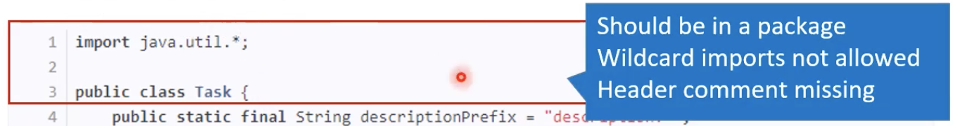

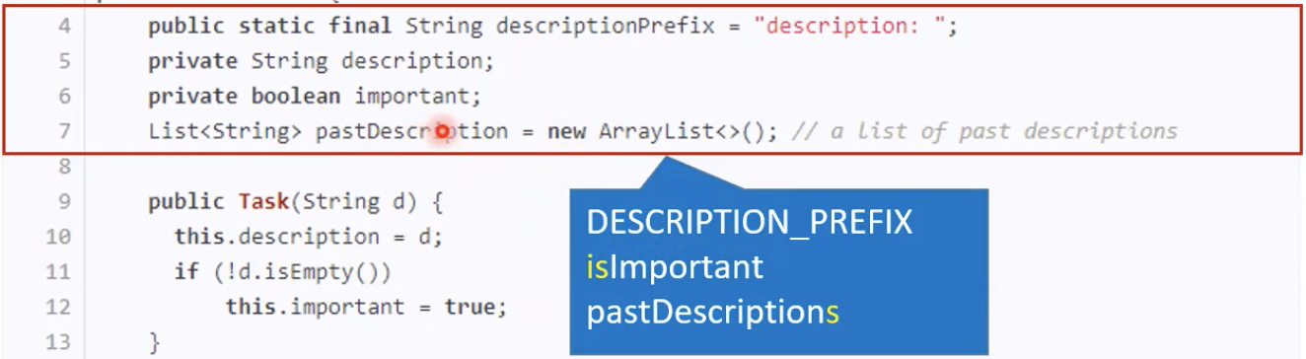

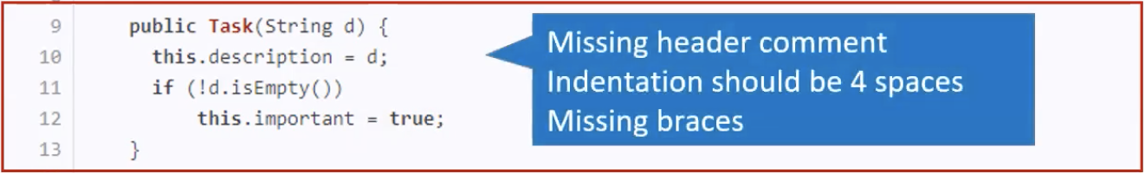

this.不是必要时不要用

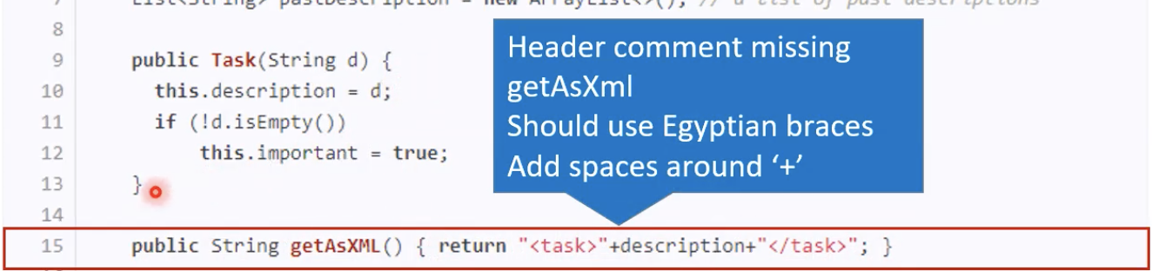

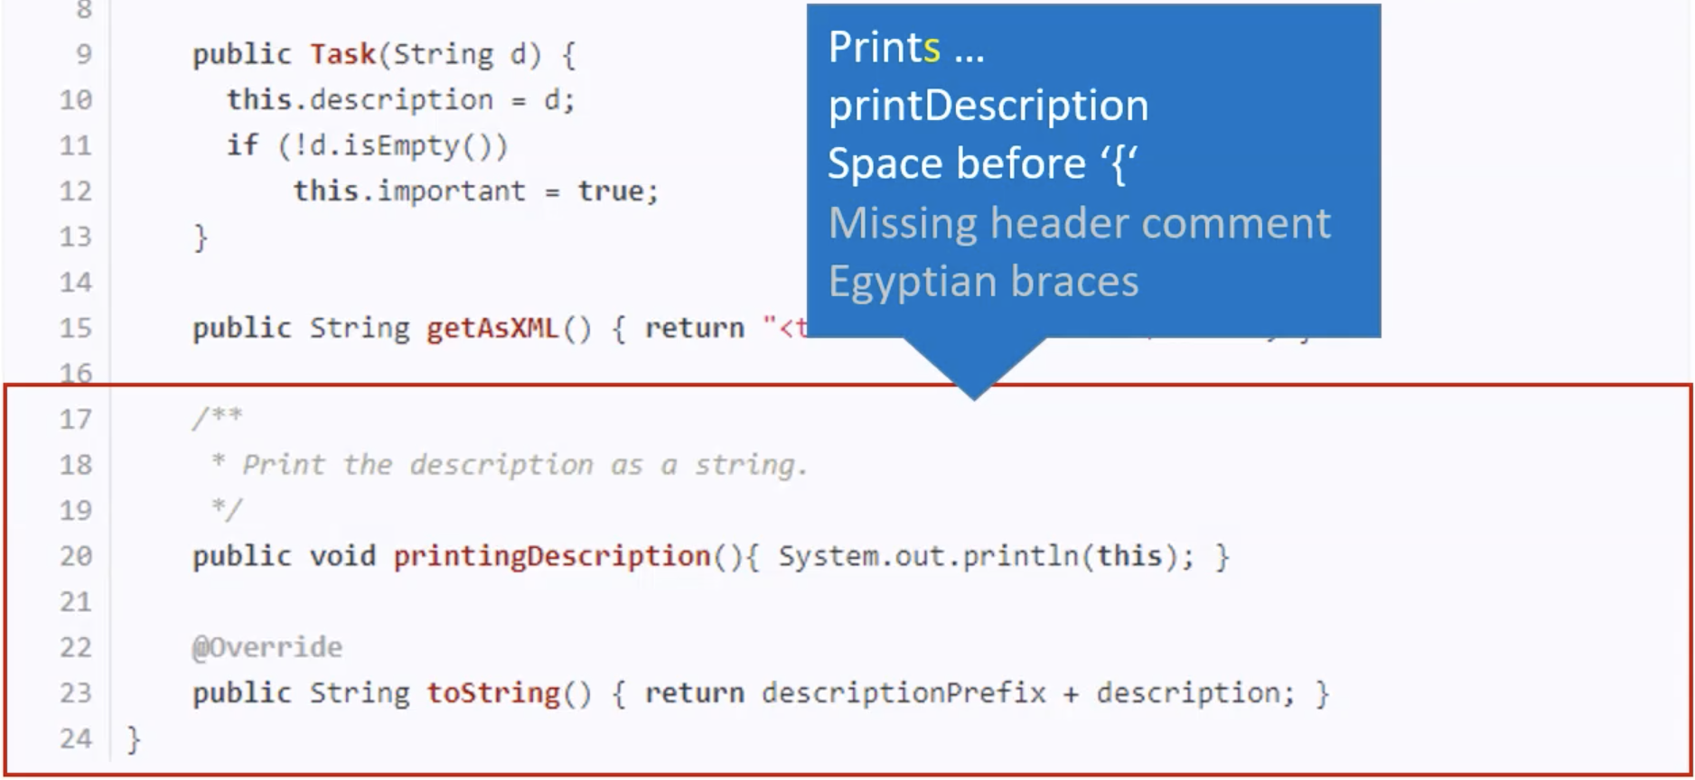

21. Developer testing is the testing done by the developers themselves.

24. **A test driver is the code** that ‘drives’ the SUT for the purpose of testing.

29. That is not the purpose of a stub: A stub is an alternative implementation of an SUT; by having two alternative implementations, we reduce the risk of bugs.

**Week 4: Models, Class/Object Diagrams: Basics, Naming, Static Analysis, Code reviews, Revision Control Software(RCS), Automating the Build Process**

<https://nus-cs2103-ay2122s1.github.io/website/schedule/week4/topics.html>

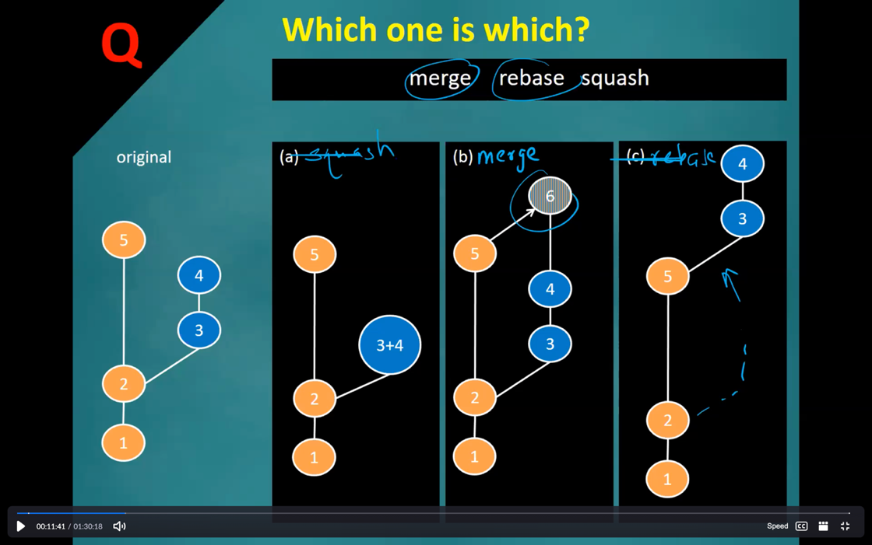

**注意行为Behaviour, 结构Structure, 交互Interaction**

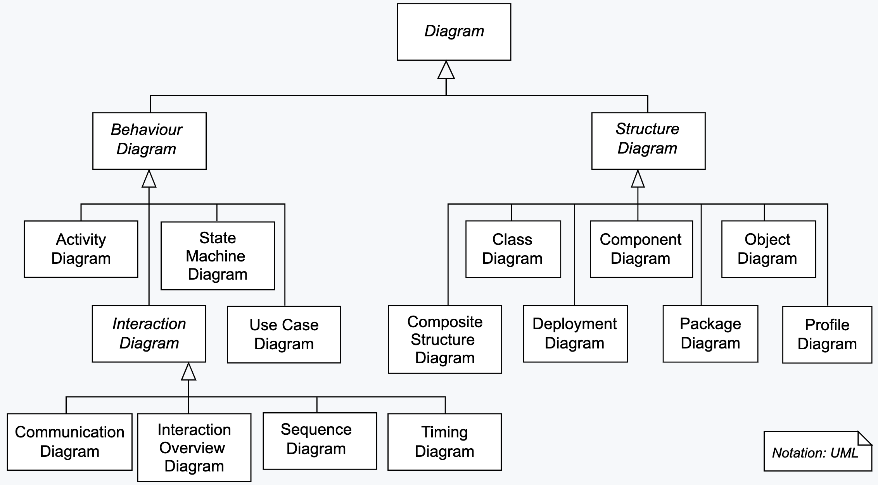

UML Object Diagrams are used to model **object structures** and UML Class Diagrams are used to model **class structures of an OO solution**.

**Class Diagram**

**The “Operations” compartment and/or the “Attributes” compartment may be omitted.**

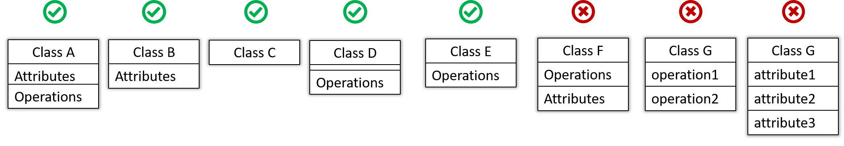

|  |  |
| --- | --- |
| + | public |
| - | private |
| # | protected |
| ~ | package private |

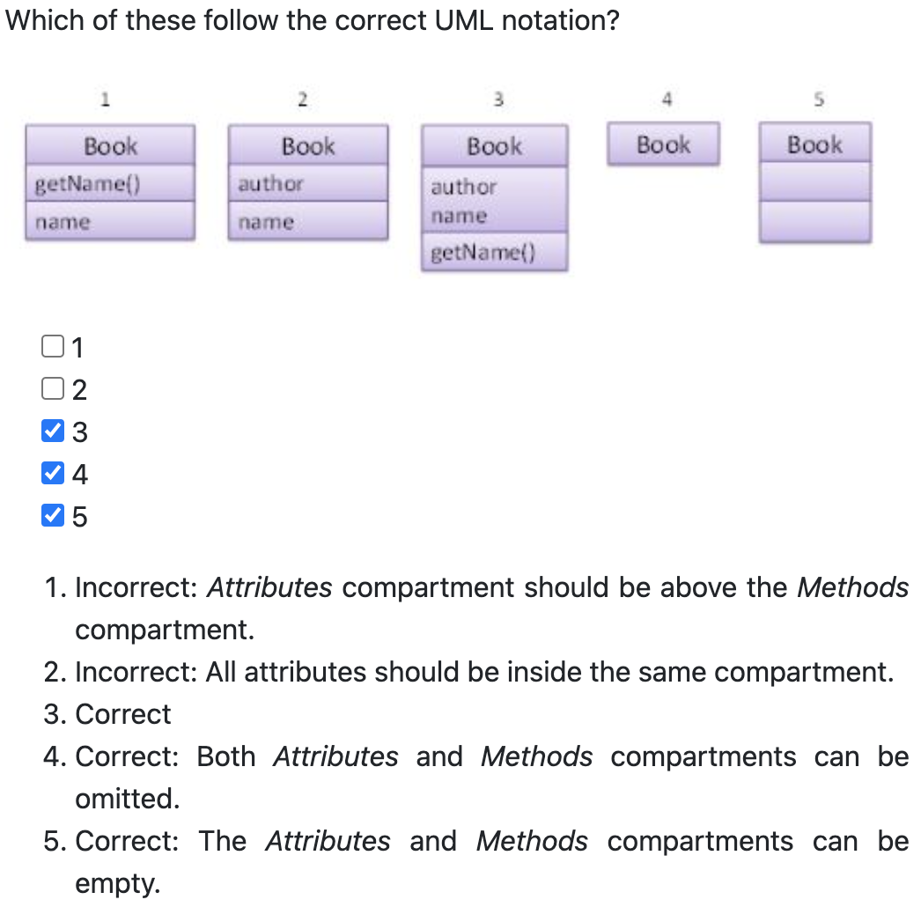

|  |  |
| --- | --- |
| Associations | 连线 |
| Labels | 按照箭头方向阅读 |
| Roles | 代表定义或实例化某个类时的名称 |
| Multiplicity | 0..1(optional associations)  1(compulsory associations)  *  n..m |
| Navigability | 箭头的方向代表可以依赖方向，例如A -> B代表A中有B |
| Bidirectional | **UML图中的双向箭头不代表就是Bidirectional**  class Foo {  Bar bar;  }  class Bar {  Foo foo;  } |
| Notes |  |
| Associations as attributes | name: type [multiplicity] = default value  **attribute和line只能二选一** |
| Inheritance |  |
| Composition (Consist) | A Book **consists** of Chapter objects. **When the Book object is destroyed, its Chapter objects are destroyed too**. |
| Aggregation | 不建议使用 |
| Dependencies | **Dependencies vs associations**  仅当依赖关系尚未以另一种方式（例如, 作为关联或继承）被图表捕获时, 才使用依赖关系箭头来指示依赖关系, 例如**Foo 类访问 Bar 中的常量,** 但从 Foo 到 Bar 没有关联/继承。  如下图的add(Player) |
| Enumerations |  |
| Abstract / static Classes | *斜体*或{}, 可用于方法或类 |
| Interfaces | **注意与Inheritance的区别,虚线, Implement的方法也要照抄**  **注意interface中的method默认是public +** |
| Association classes | Goo是Association class, Foo和Bar是普通class |

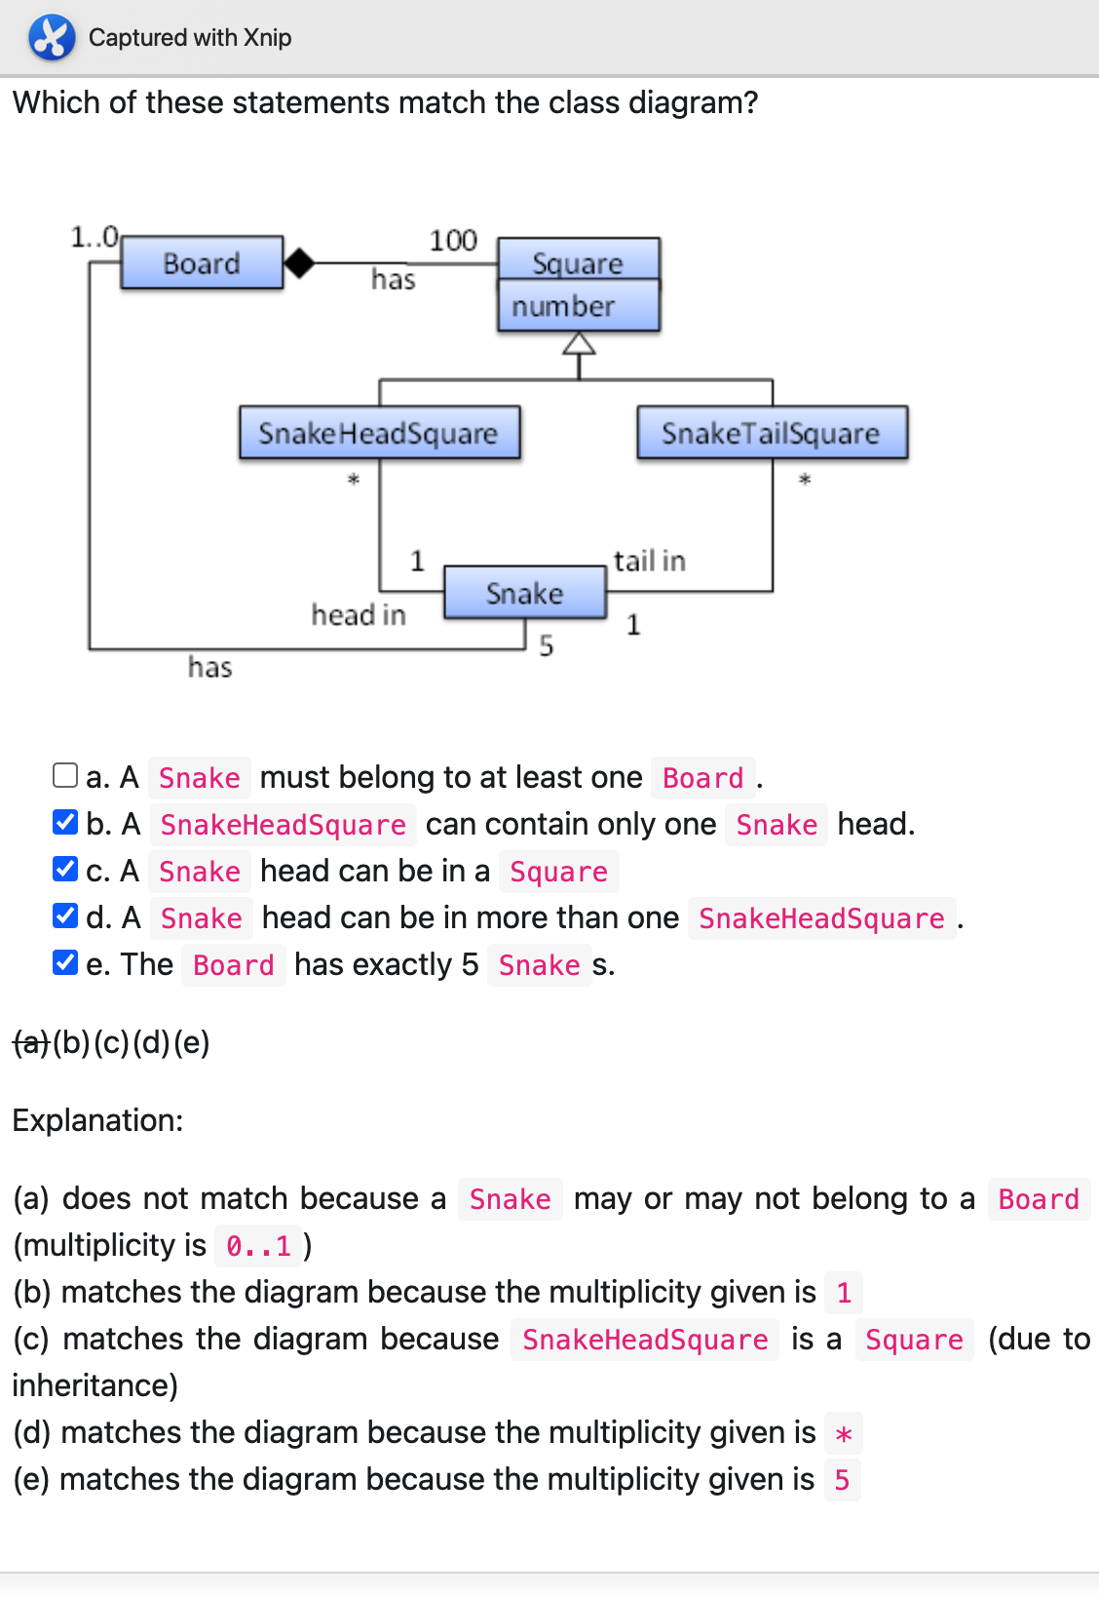

**Object Diagram: 注意下划线**

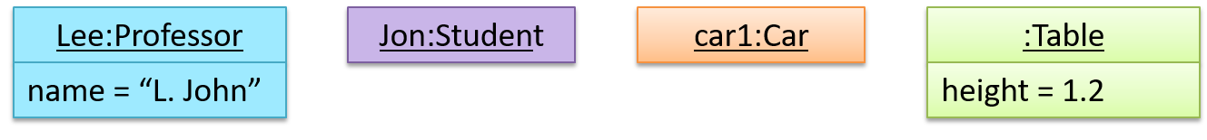

Multiple object diagrams can correspond to a single class diagram.

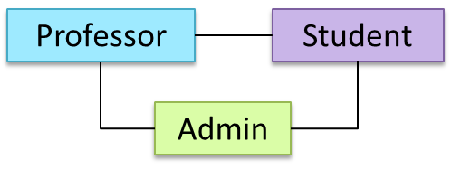

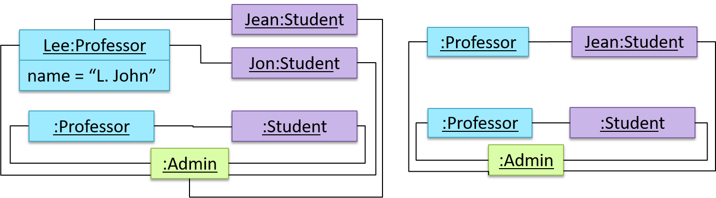

Static analysis: 执行代码前

Dynamic analysis: 执行代码后

**Object Diagram represents the object structure at a specific point of time. 一个Class Diagram可以有多个Object Diagram。**

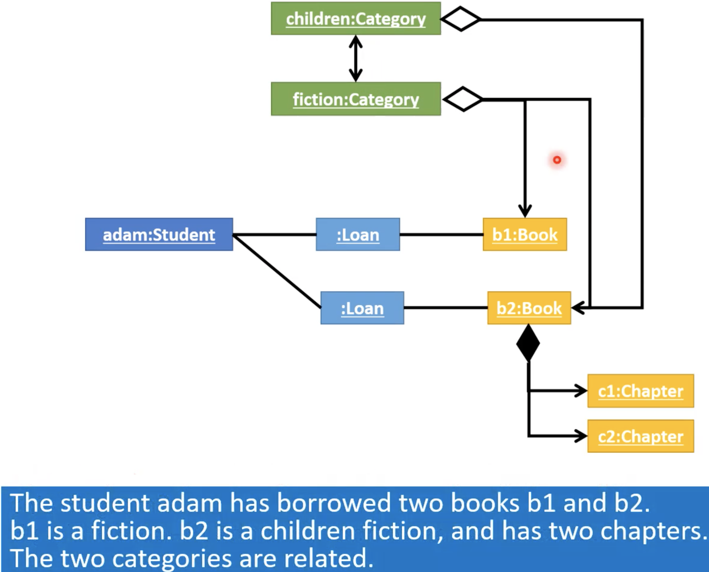

11. Multiple models of the same entity may be needed to capture it fully. In addition to a class diagram (or even multiple class diagrams), a number of other diagrams may be needed to capture various interesting aspects of the software.

15. In the following class diagram, the UML term used for the ‘+’ and ‘-’ signs to is **visibility** ~~accessibility~~.

36. **Composition is a whole-part relationship, aggregation is a container-containee relationship.**

43. Class names should be nouns and method names should be verbs.

46. As per the textbook, PR reviews is **one of the three ways (Pull Request reviews, In pair programming, Formal inspections)** of reviewing code.

47. As per the article (i.e., 10 tips for reviewing code you don’t like) given in the resources section of the textbook, it is recommended to phrase your comments as questions.

49. Linters are a subset of static analyzers.

**Week 5: Requirements, Code Quality, Refactoring, Assertions, Revision Control Software(RCS)**

<https://nus-cs2103-ay2122s1.github.io/website/schedule/week5/topics.html>

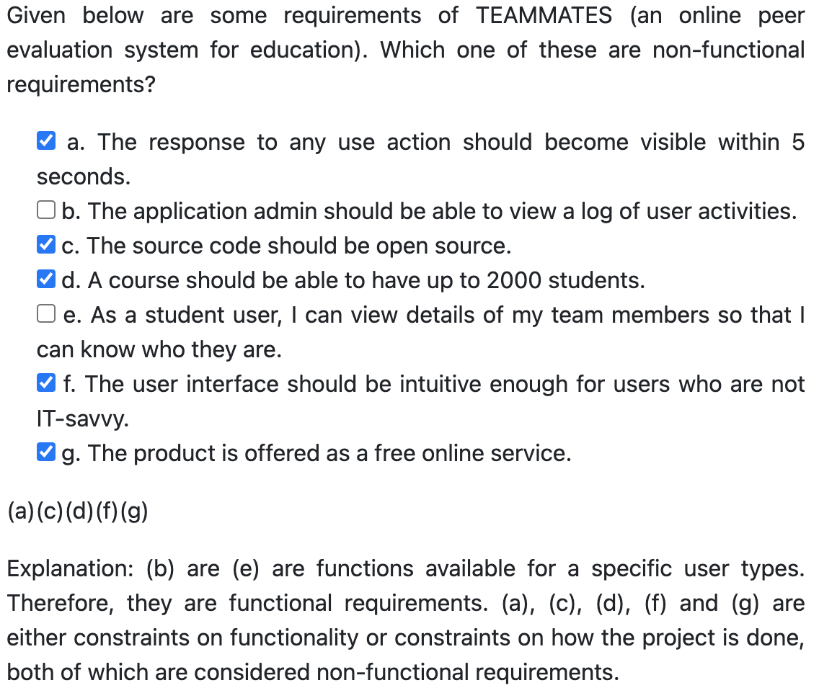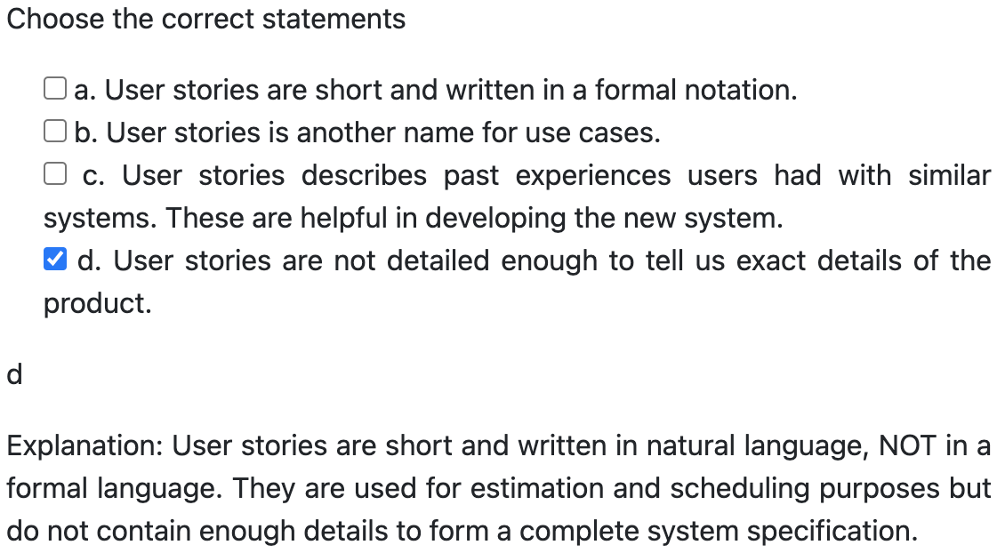

Avoid long methods

Avoid deep nesting

Avoid complicated expressions

Avoid magic numbers

Make the code obvious

Structure code logically

Do not 'Trip Up' reader

Practice KISSing (keep it simple, stupid)

Avoid premature optimizations

Single Level of Abstraction Principle (SLAP) hard

Make the happy path prominent

Use the default branch

Don't recycle variables or parameters

Avoid empty catch blocks

Delete dead code

Minimize scope of variables

Minimize code duplication: DRY (Don't Repeat Yourself) Principle

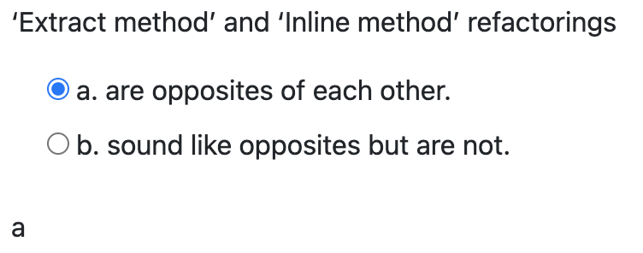 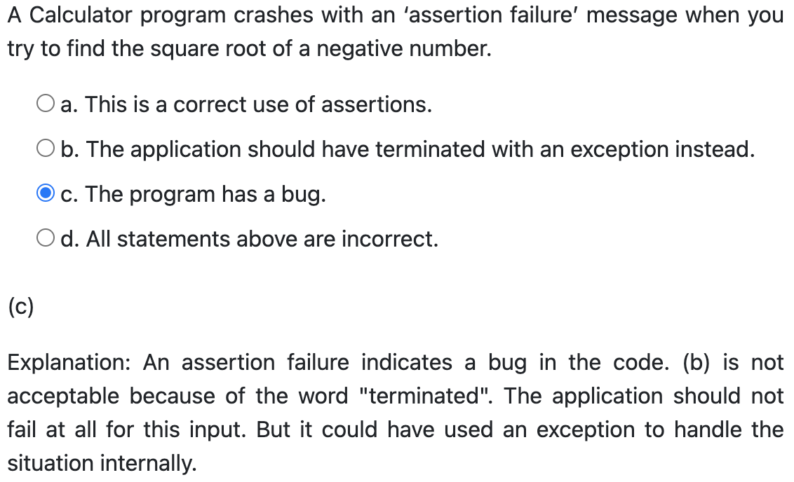

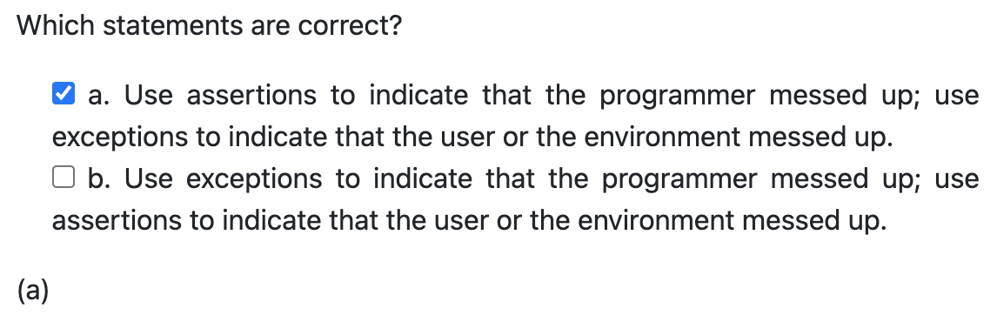

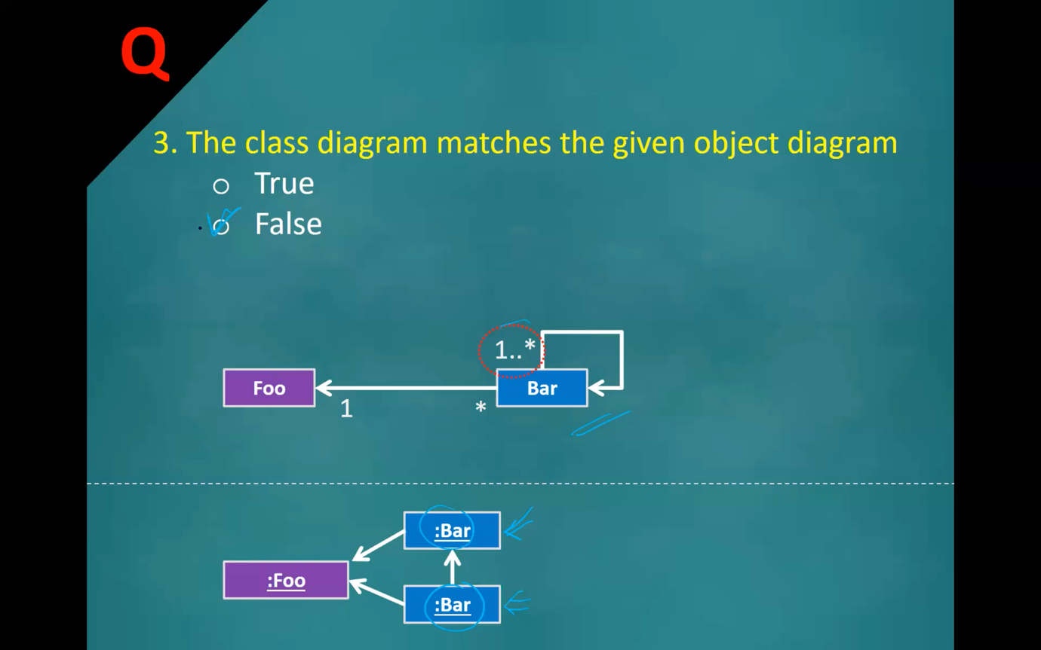

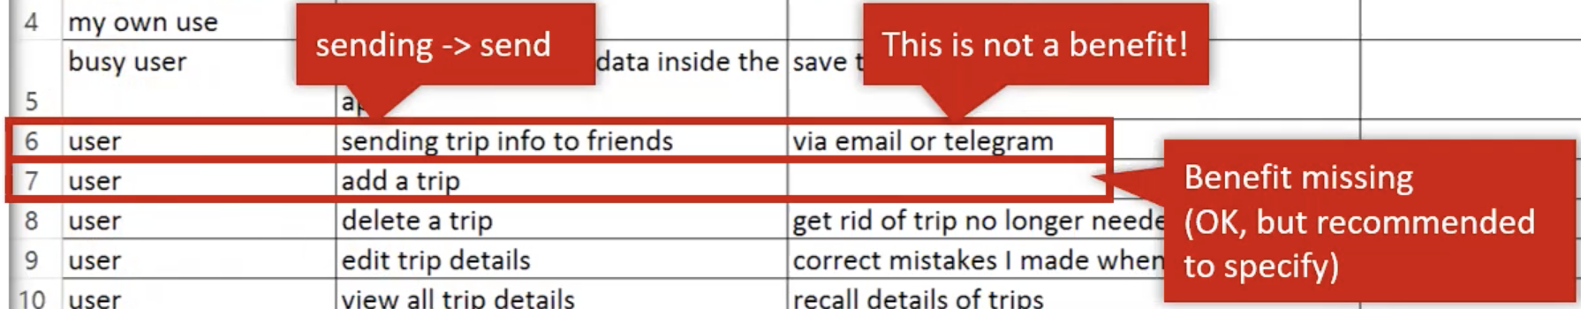

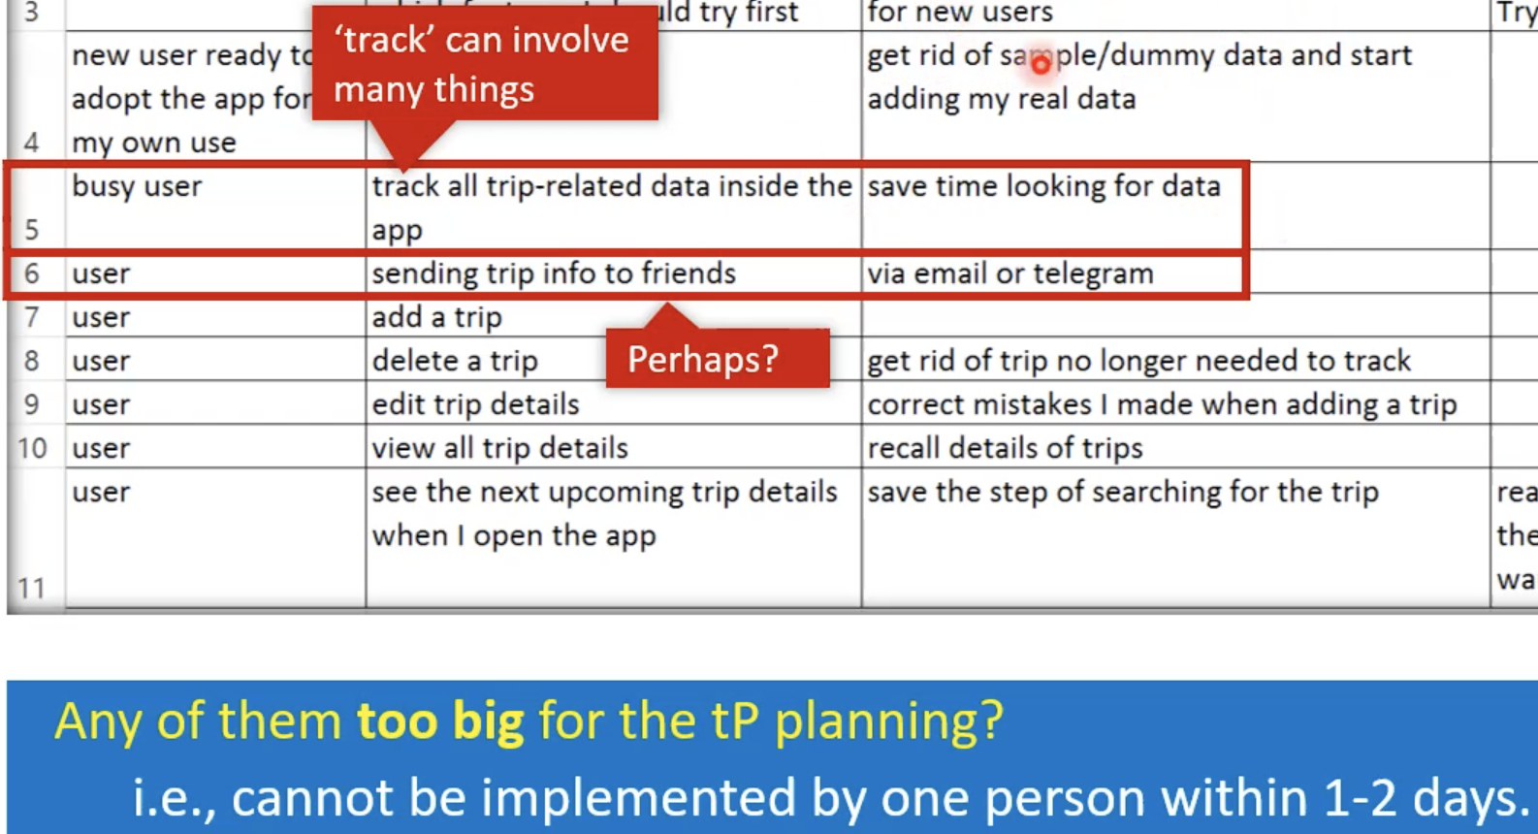

14. **Requirements should be implementation-free**.

24. High-level user stories are sometimes called **themes or epics**.

25. You can add other useful info (Conditions, Priority, Size, Urgency) to a user story.

27. **User stories can capture non-functional requirements** too because even NFRs must benefit some stakeholder.

52. Refactoring can cause regressions.

**Week 6: Sequence Diagrams, Architecture Diagrams, IDEs, Logging**

<https://nus-cs2103-ay2122s1.github.io/website/schedule/week6/topics.html>

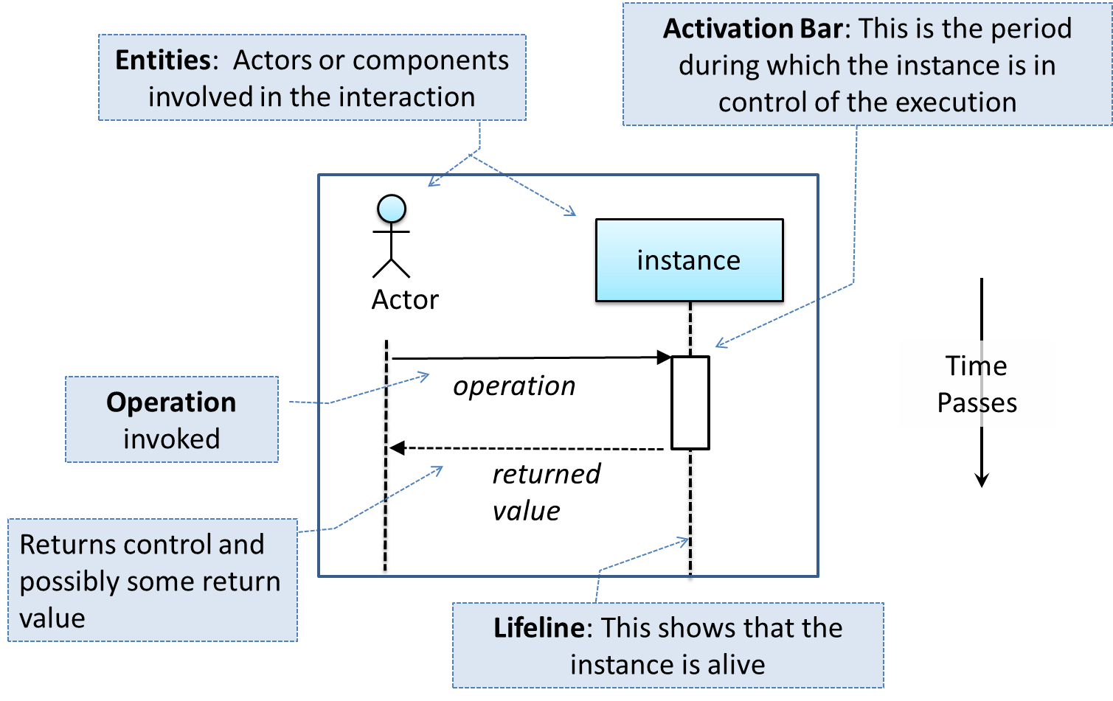

**方法调用是实线箭头，方法返回是虚线箭头**

**instance有冒号无下划线，例:Abc**

**activation bars和return arrows可省略**

**注意下面错误实例**

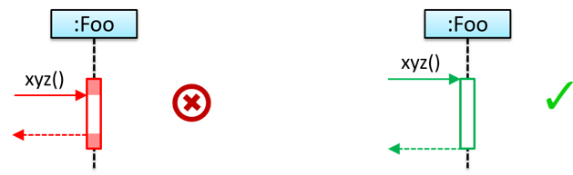 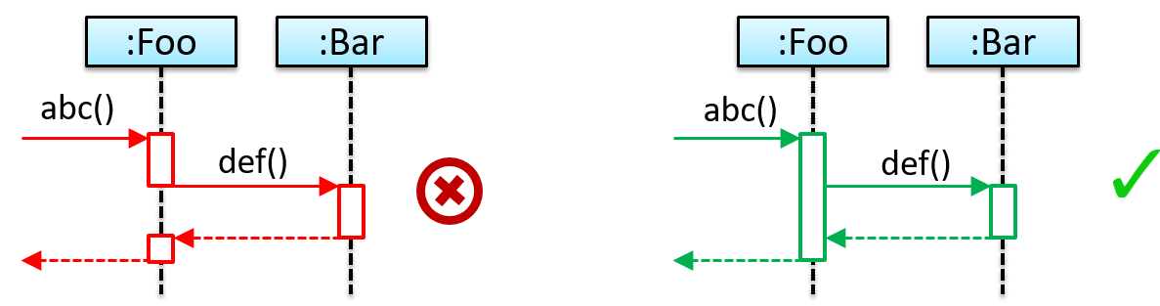

|  |  |
| --- | --- |
| Loops | **右下角不是直角, 没有for while之分, 条件中括号[]不能漏了**   |
| Object Creation | **箭头指向Entity, 调用Constructor, Activation Bar紧贴Entity**   |
| Object Deletion |  |
| Self-Invocation |  |
| Alternative Paths | **右下角不是直角, 类似if...else..., 条件中括号[]不能漏了** |
| Optional Paths | **右下角不是直角, 类似if..., 条件中括号[]不能漏了** |
| Static Methods |  |
| Reference Frames | **UML 使用ref允许省略交互的一部分并显示为单独的序列图** |
| Parallel Paths | **注意并行路径的运行不分先后** |

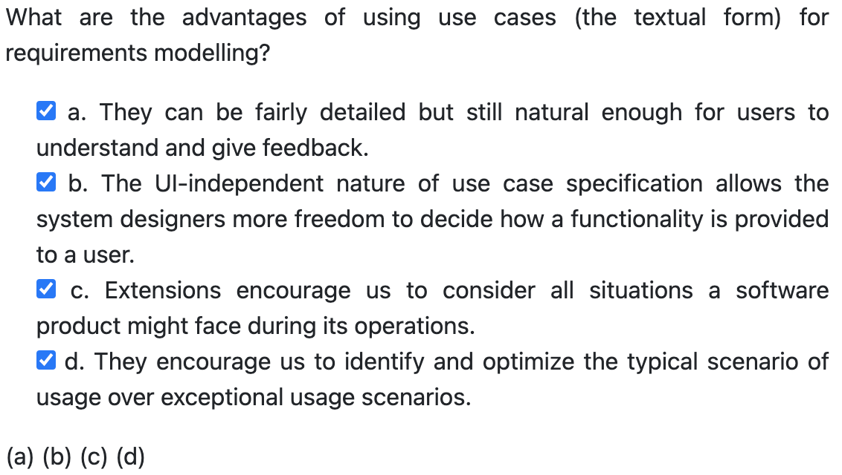 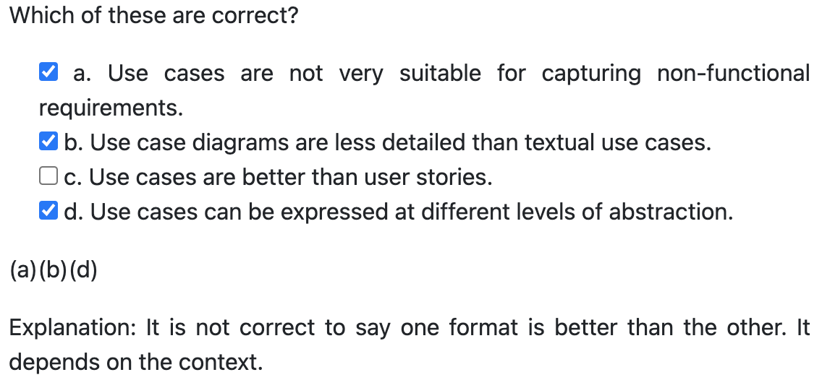

|  |  |
| --- | --- |
| Top-down | Big and novel systems. |
| Bottom-up | A variation of an existing system or re-purposing existing components to build a new system. |
| Mix | Design the top levels using the top-down approach but switch to a bottom-up approach when designing the bottom levels. |
| Agile敏捷 |  |

Work Breakdown Structure (WBS): depicts information about tasks and their details in terms of subtasks.

Centralized RCS (CRCS for short): uses a central remote repo that is shared by the team.

Distributed RCS (DRCS for short, also known as Decentralized RCS): allows multiple remote repos

31. Architecture diagrams are free-form diagrams.

32. The software architecture shows the overall organization of the system. It can be viewed as a very high-level design of the software.

34. Use cases should not be used as the sole means to specify requirements because they are not good for capturing requirements that do not involve a user interaction.

35. 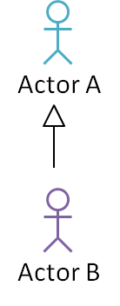 This means all use cases available to Actor A are also available to Actor B.

**Week 7: Use Cases, High-Level View, Abstraction, Coupling, Cohesion, Integration Approaches, Project Mgt**

<https://nus-cs2103-ay2122s1.github.io/website/schedule/week7/topics.html>

**Use Case: capture the functional requirements of a system.**

**UI details are usually omitted.**

* Software System
* Use case
* Actor
* Preconditions
* Guarantees: what the use case promises to give us at the end of its operation.
* Main Success Scenario (MSS)
  + **Inclusions**: A use case can include another use case. Underlined text.
* Extensions: describe exceptional/alternative flow of events.

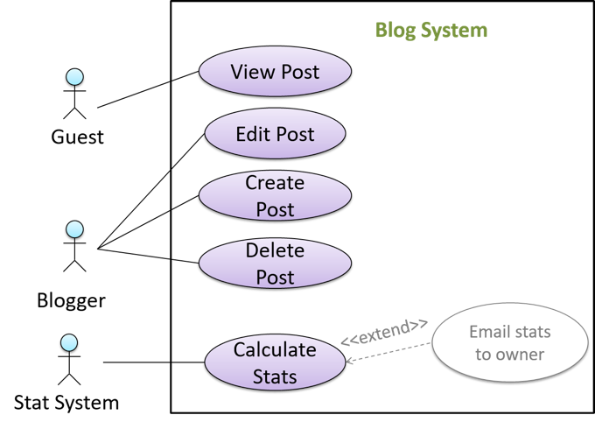 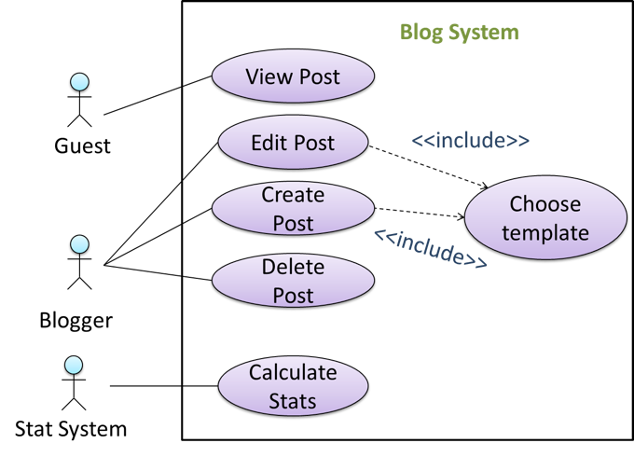

**箭头方向: Email... is an extension to Calculate... 箭头方向: Edit... include Choose...**

15, 17. An actor (in a use case) is a role played by a user. An actor can be a human or another system. Actors are not part of the system; they reside outside the system.

42. The agile design approach does not produce a fully-documented set of design models before coding begins.

51. X is coupled to Y if a change to Y can **potentially (but not necessarily always)** require a change in X.

61. It is not recommended to inflate task estimates to create hidden buffers.

68. Git is a DRCS. Subversion (SVN) is a CRCS.

**Week 8: Integration Testing, System Testing, Automated testing of GUIs, Acceptance testing (aka User Acceptance Testing (UAT)), Alpha/Beta Testing, Exploratory vs Scripted Testing, Dependency Injection (stub), TDD**

<https://nus-cs2103-ay2122s1.github.io/website/schedule/week8/topics.html>

**Integration tests** are additional test cases that focus on the interactions between the parts, **not using stub**.

Test-Driven Development(TDD) advocates writing the tests before writing the SUT, while evolving functionality and tests in small increments.

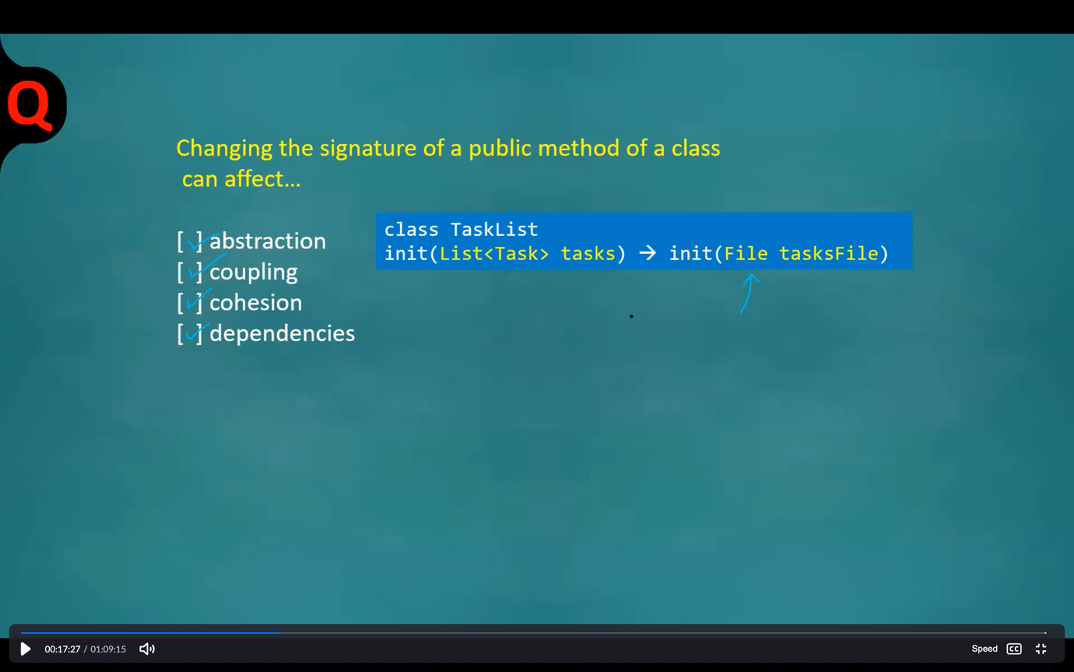

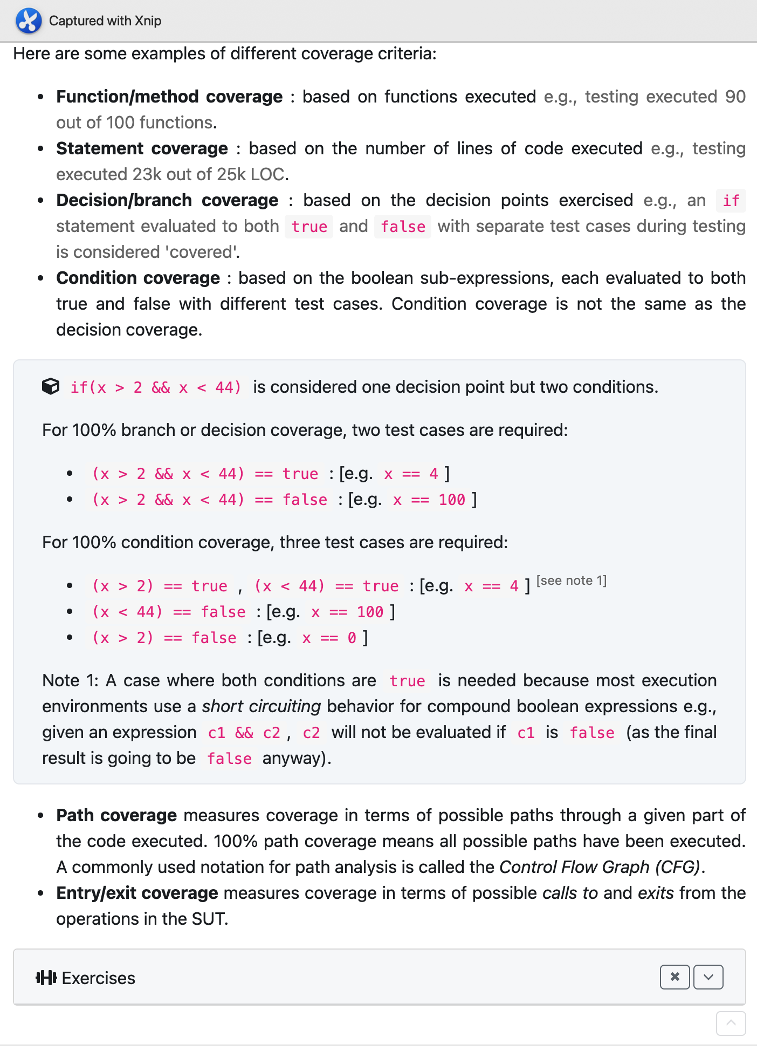

Part 2:

2. Integration testing is **not simply** a case of repeating the unit test cases **using the actual dependencies** (instead of the stubs used in unit testing). Instead, integration tests are **additional test cases** that focus on the interactions between the parts.

3. The difference between pure unit/integration testing and hybrid unit/integration testing is that the pure approach has one extra testing step, **hybrid remove stub**.

6. Usability testing and portability testing is part of system testing. So is performance testing.

9. Acceptance testing (aka User Acceptance Testing (UAT) also be done by professional testers representing the users.

10. In some projects, one document serves as both the requirements specification and the system specification.

12. **Acceptance testing focus more on positive test cases.**

25. Coverage analysis is usually a dynamic analysis.

26. 100% path coverage can require more test cases than 100% statement coverage of the same code. A test suite can execute all statements without necessarily executing all possible paths of the code.

27. 100% condition coverage can require more test cases than 100% branch coverage of the same code. A branch may require more than one condition to be true.

28. Test coverage is a metric used to measure the extent to which testing exercises the SUT.

<https://nus-cs2103-ay2122s1.github.io/website/schedule/week8/tutorial.html>

Class Diagram

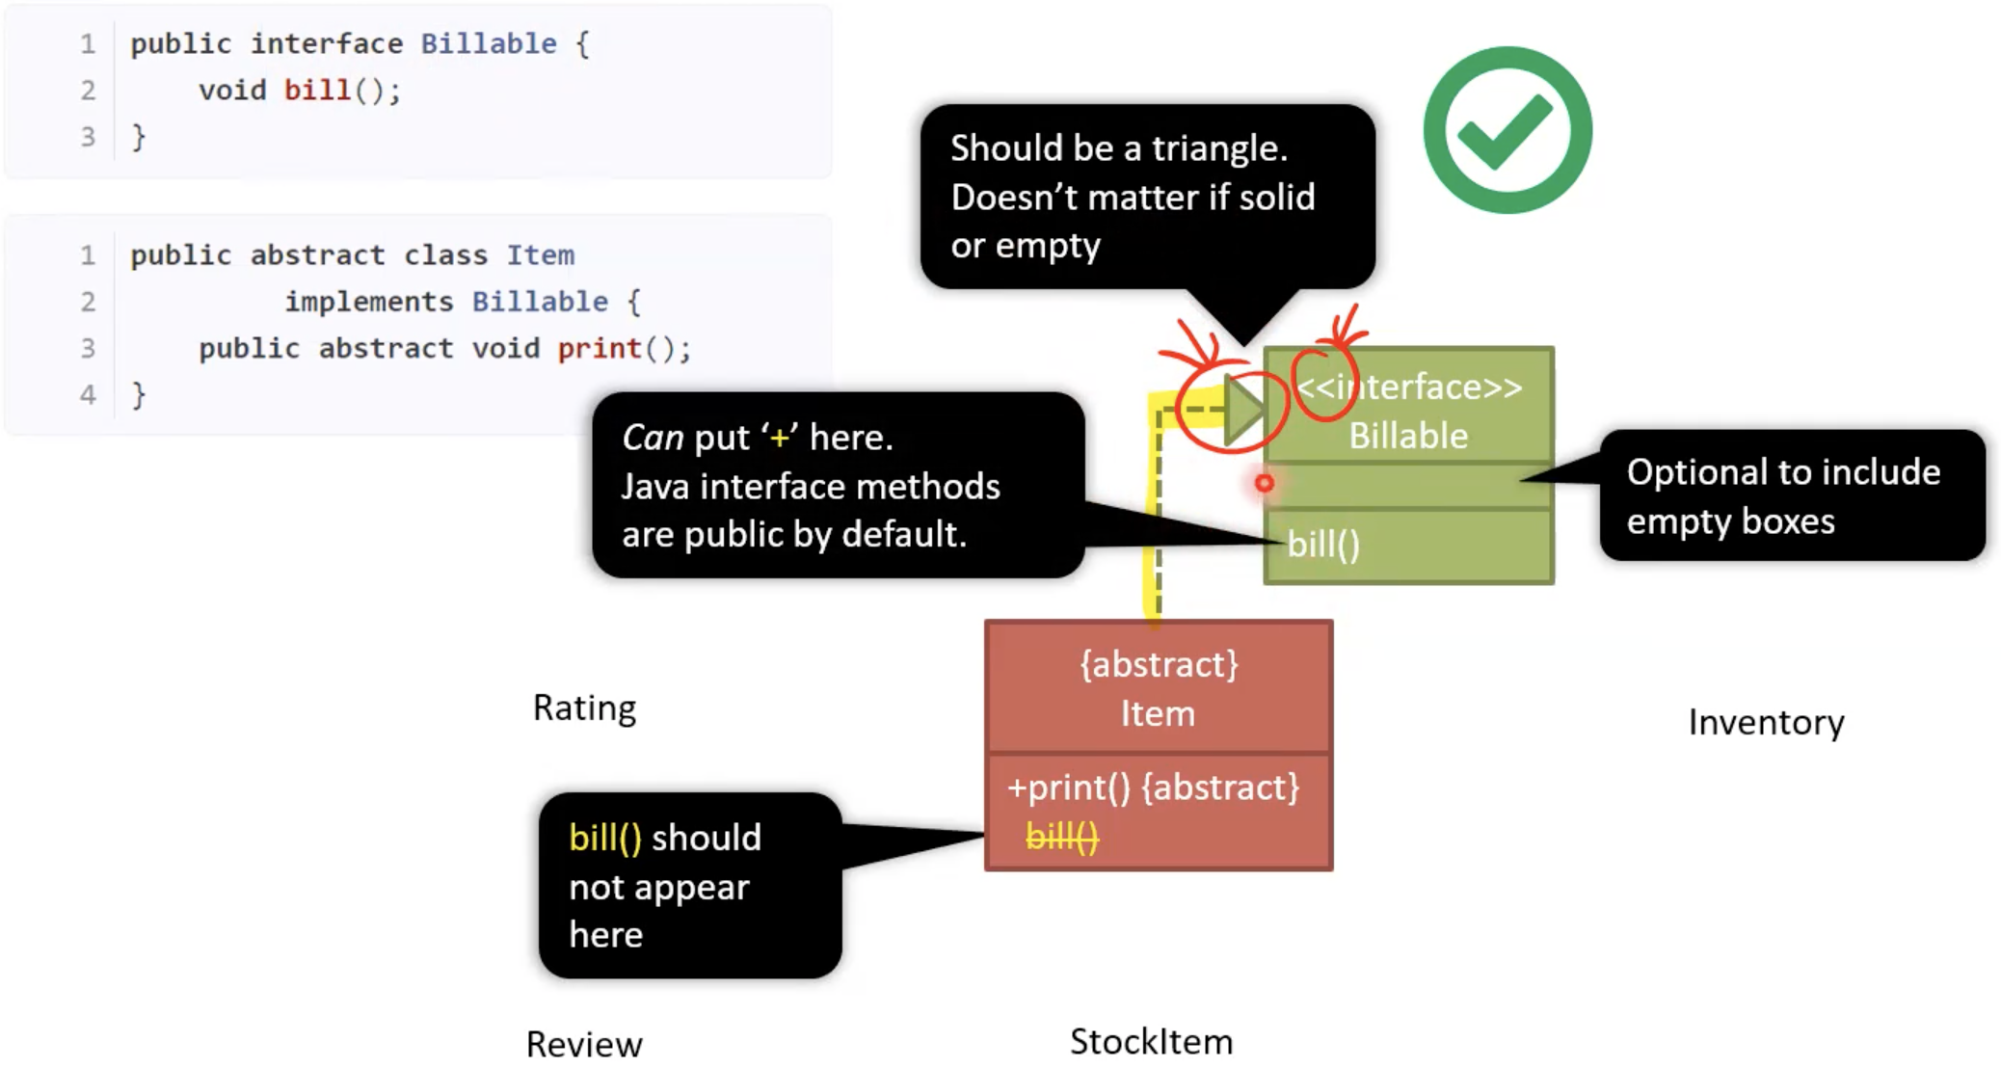

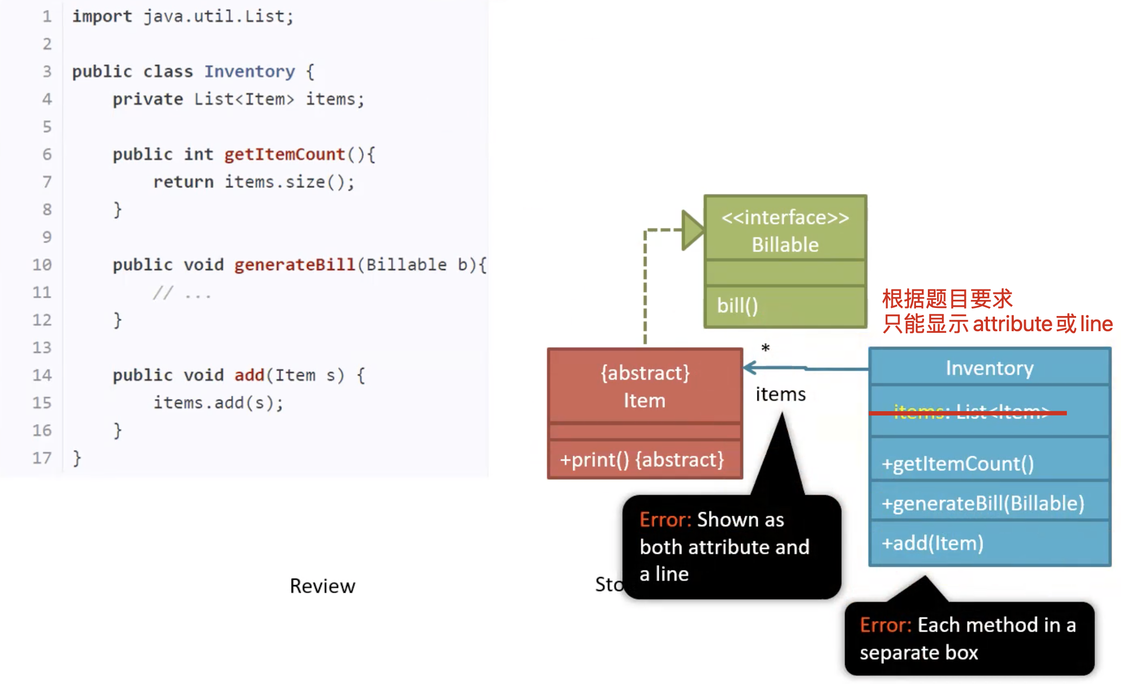

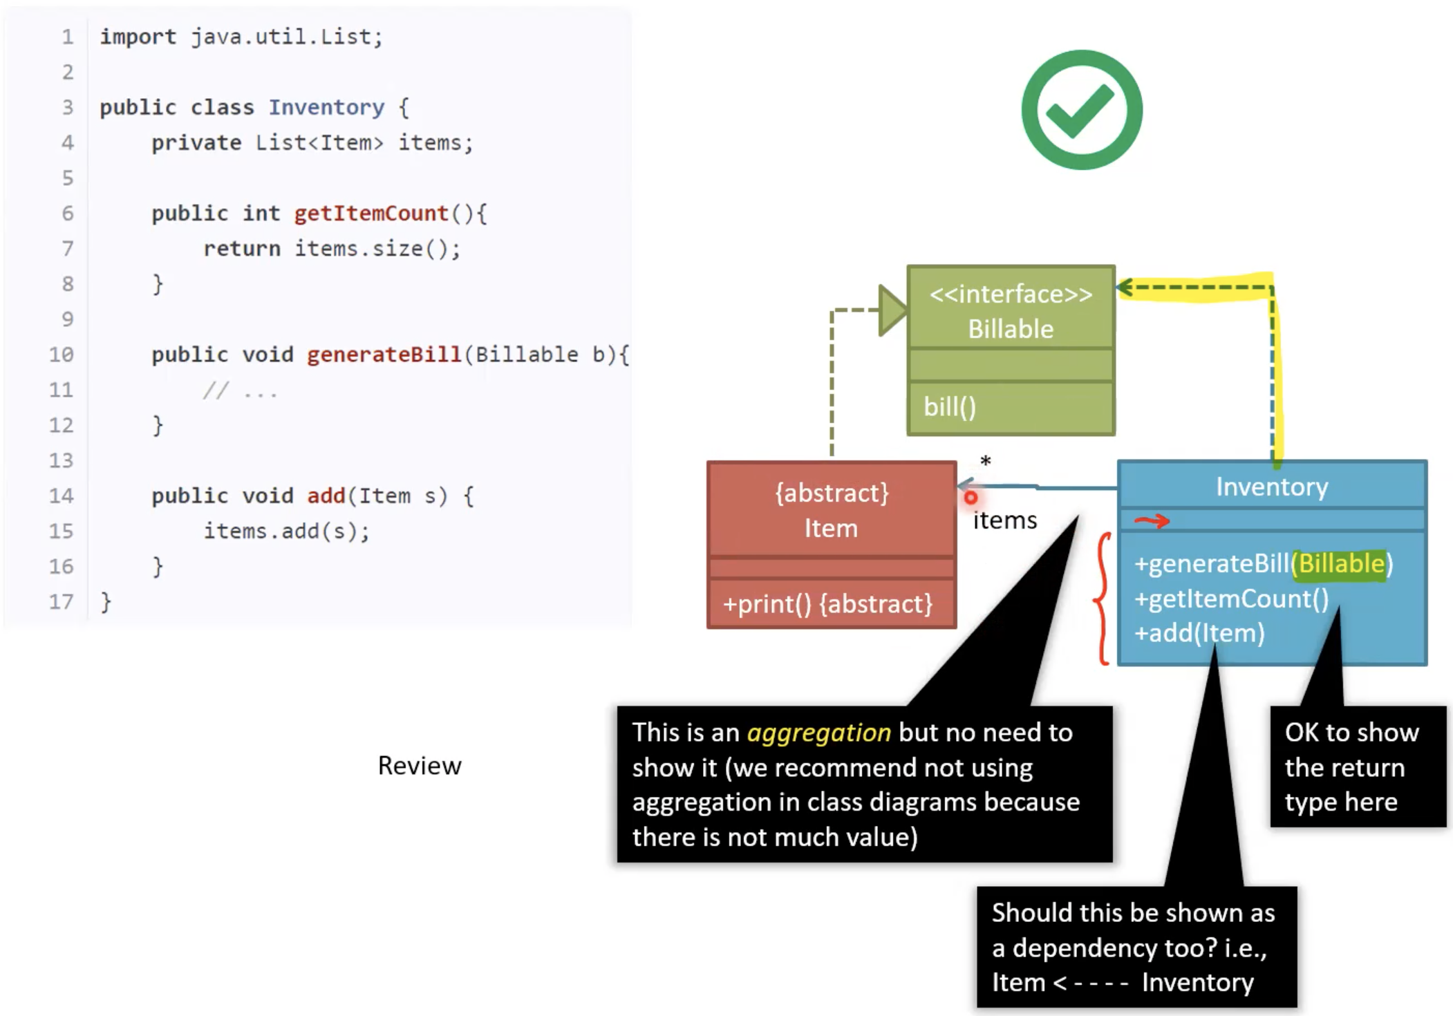

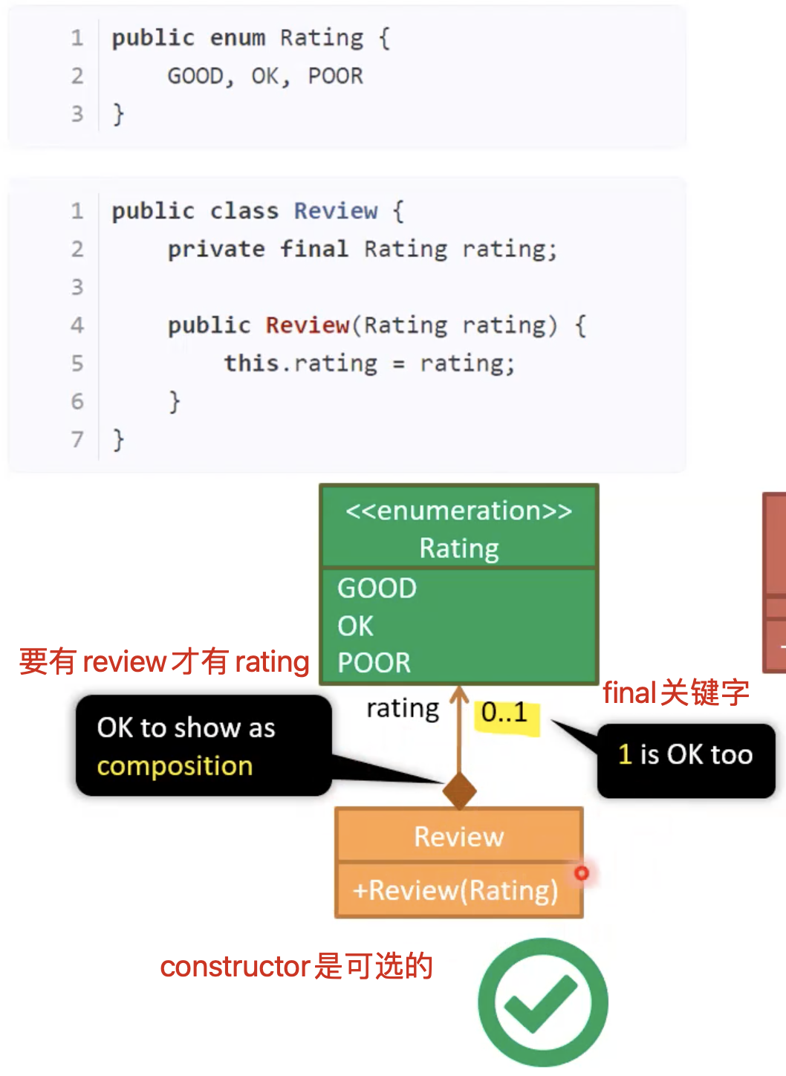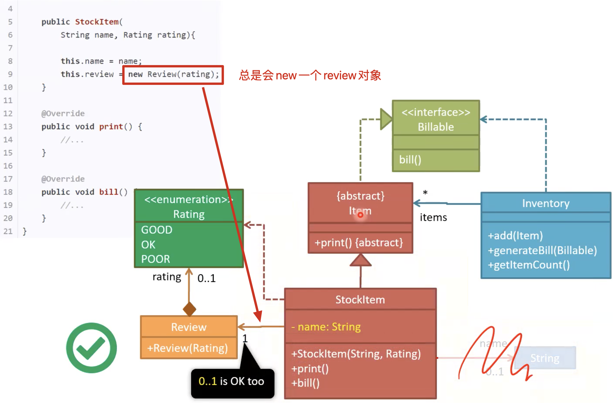

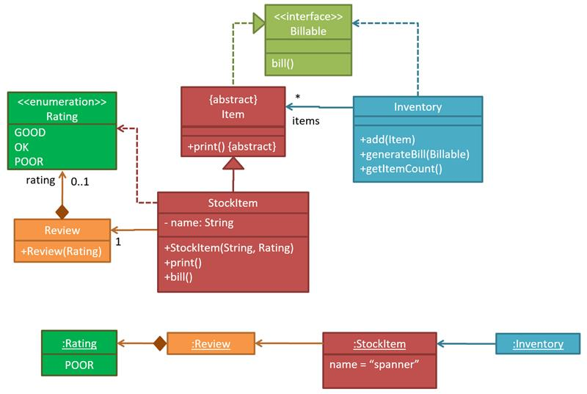

Object Diagram

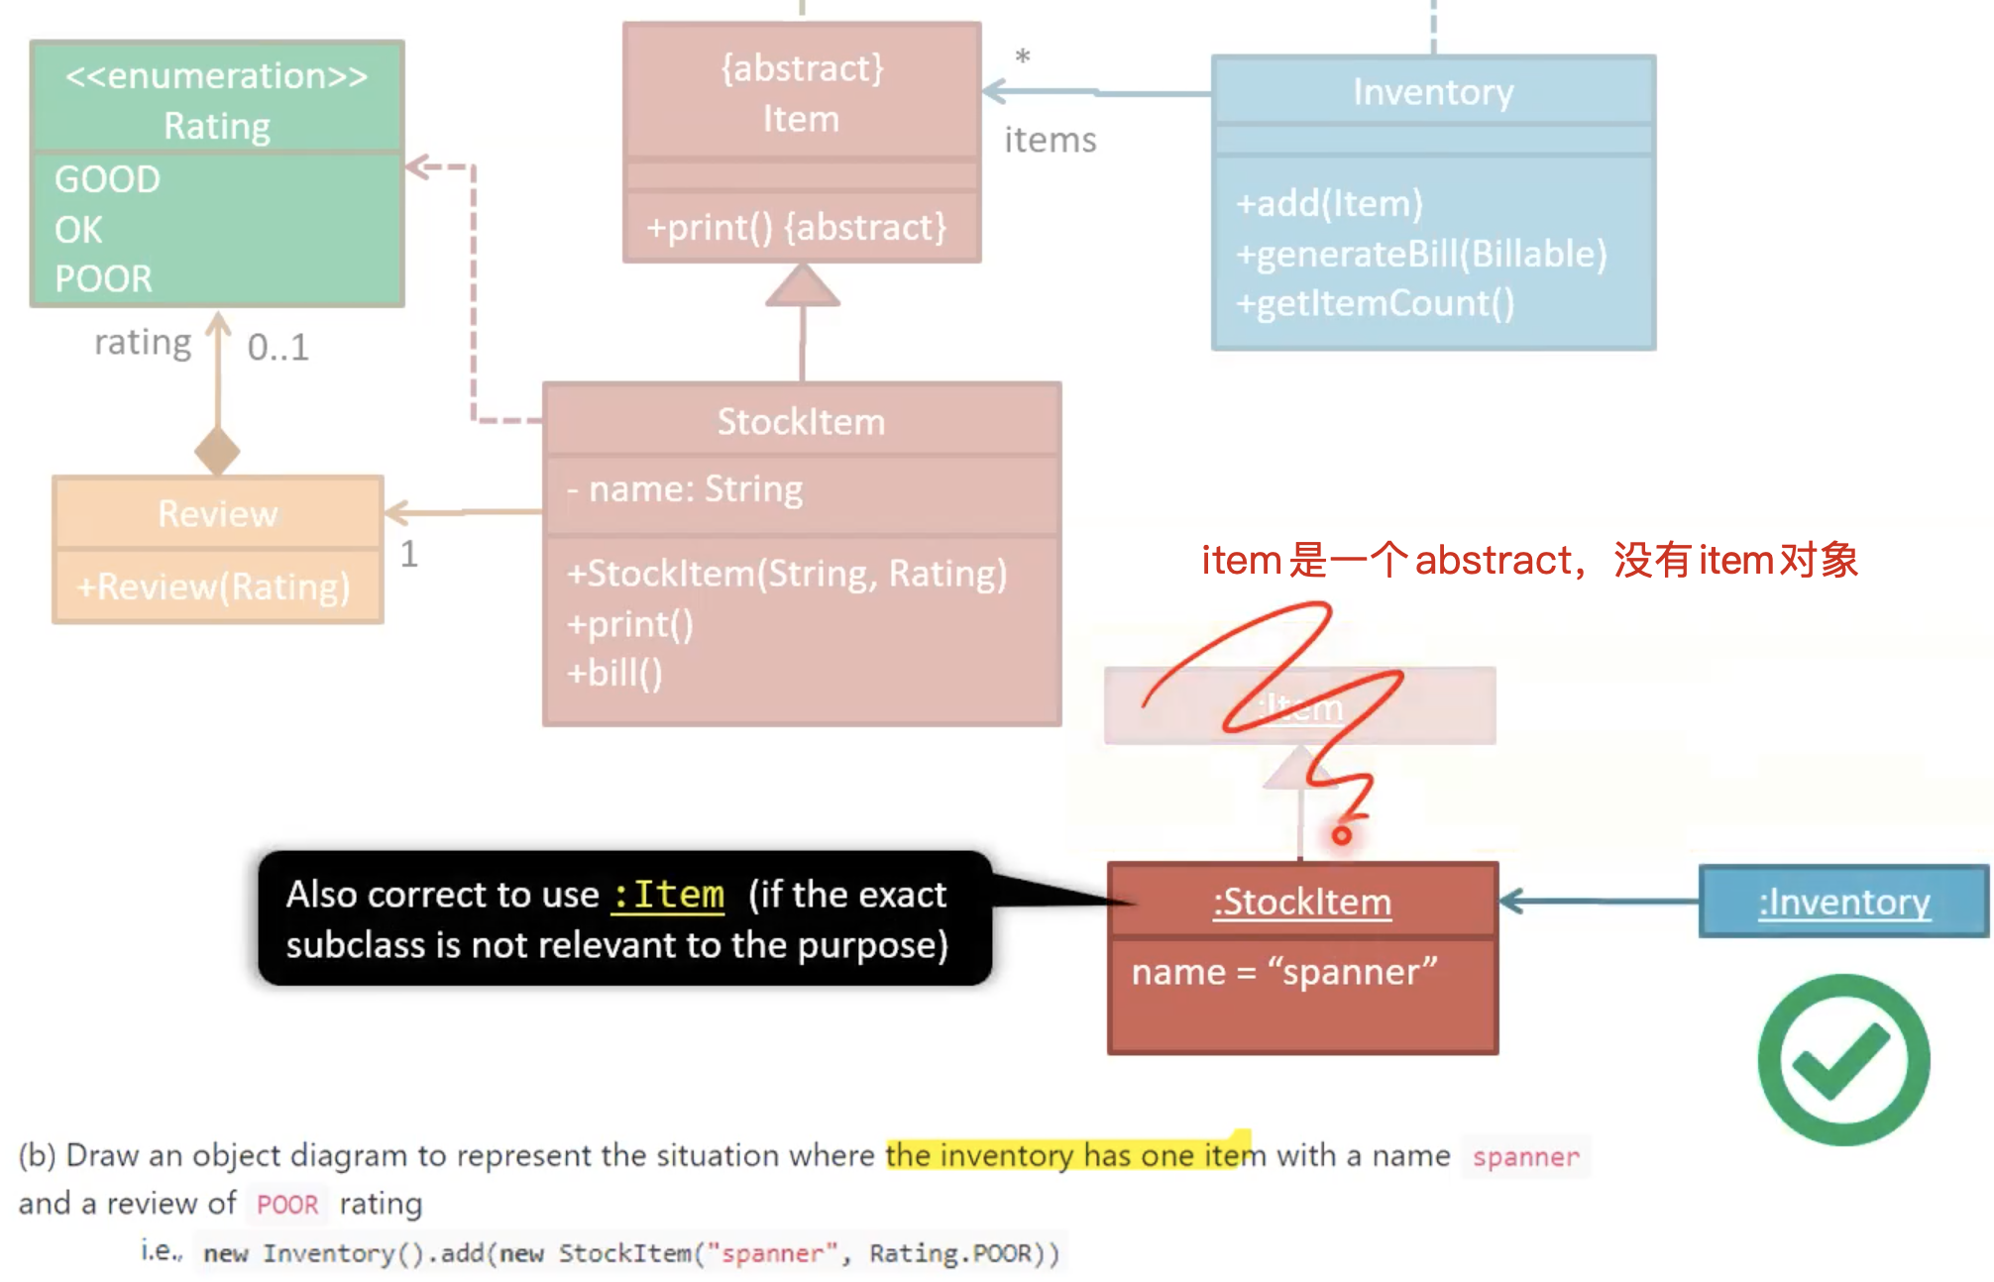

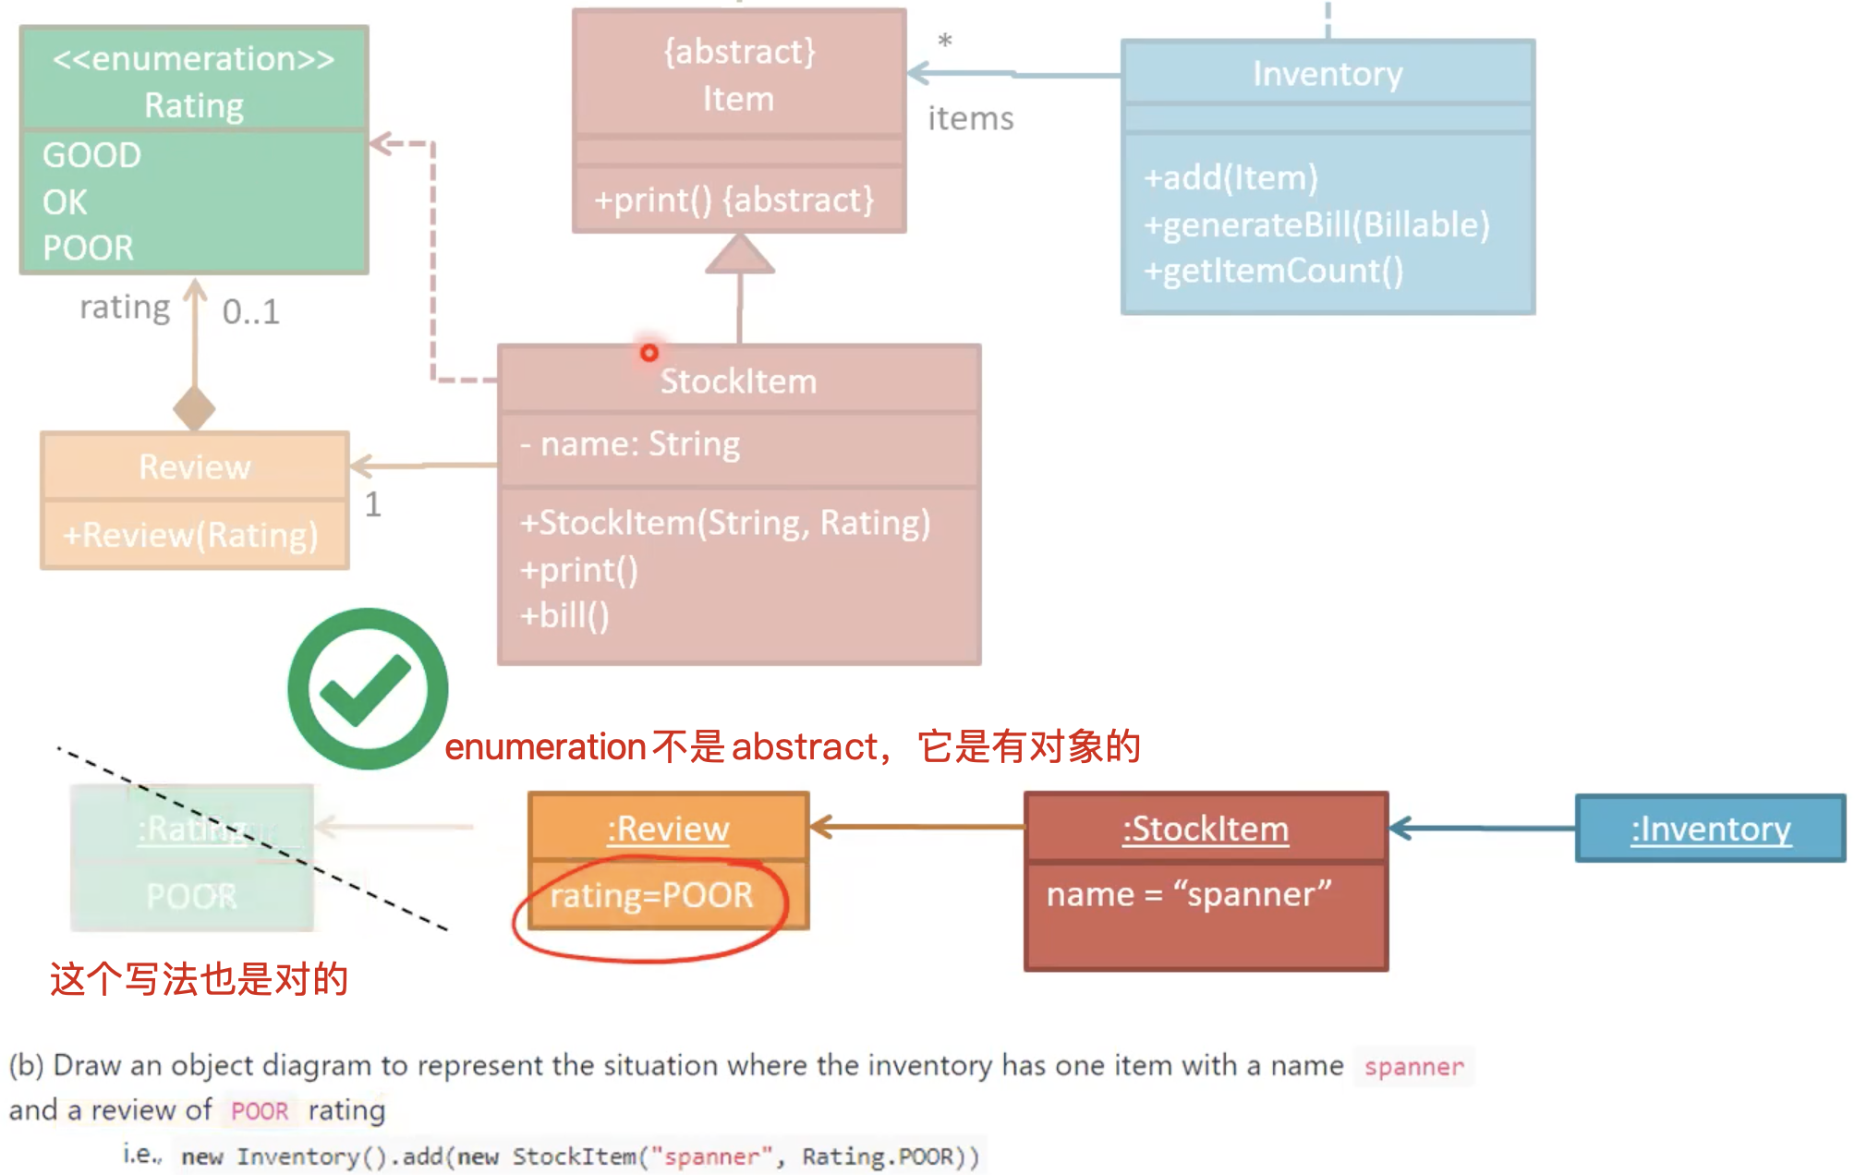

Sequence Diagram

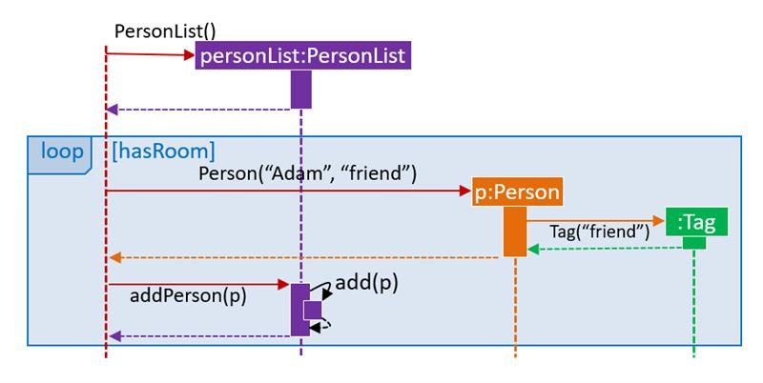

**Week 9: OO Domain Models, Activity Diagrams, Architecture Diagrams, Design Principles, SDLC Agile, Developer Guide**

<https://nus-cs2103-ay2122s1.github.io/website/schedule/week9/topics.html>

**Class diagrams** that are used to **model the problem domain (do not contain solution-specific classes)** are called conceptual class diagrams or OO domain models (OODMs).

OODM notation is similar to class diagram notation but **omit methods (operations) and navigability**.

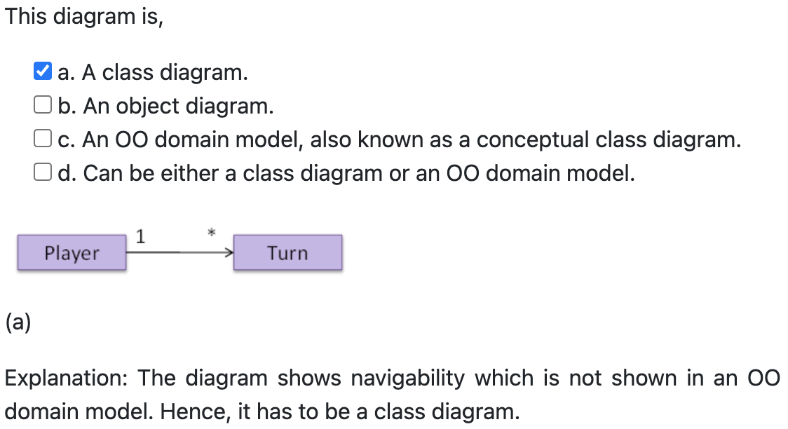 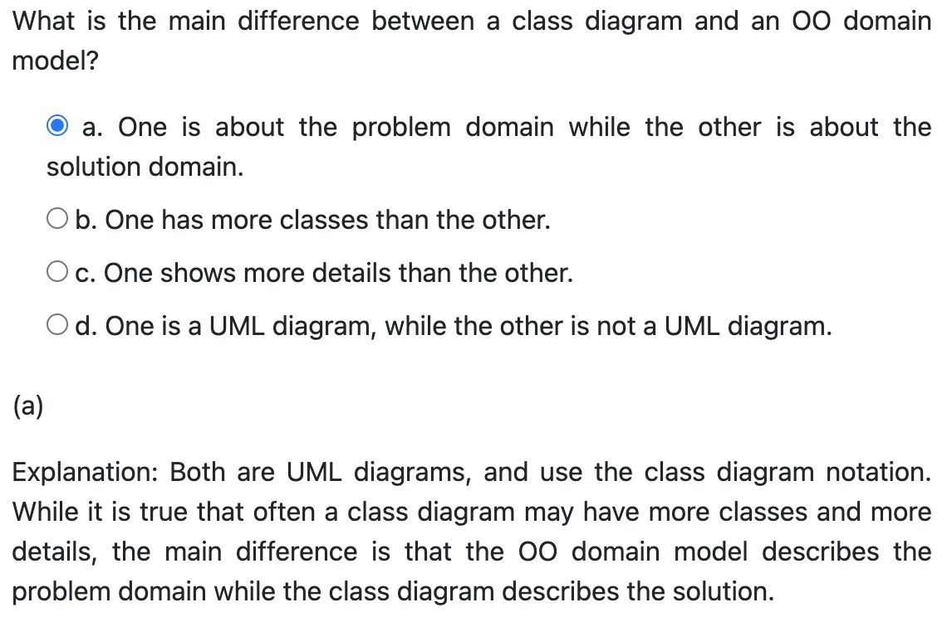

|  |  |
| --- | --- |
| Linear Paths |  |
| Alternate Paths | **条件中括号[]不能漏了** |
| Parallel Paths | **必须要把两个Action都Join了后才能继续下一步** |
| 省略 | **省略合并节点, 多个箭头可以从同一个分支节点开始, 省略[Else]条件** |
| Rakes |  |
| Swim Lanes |  |

**do-while**

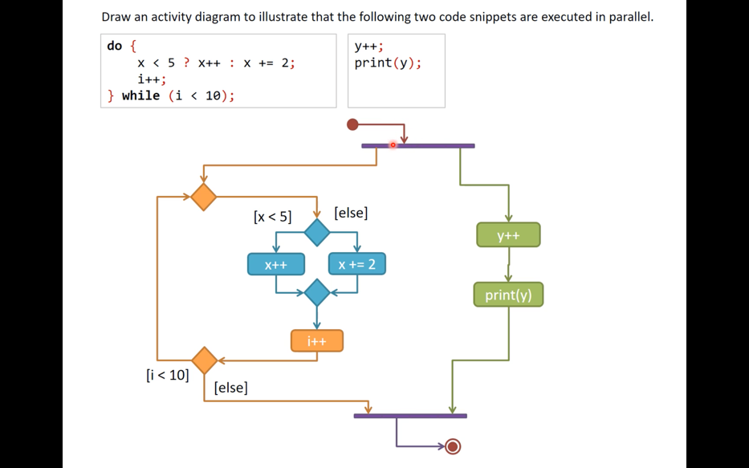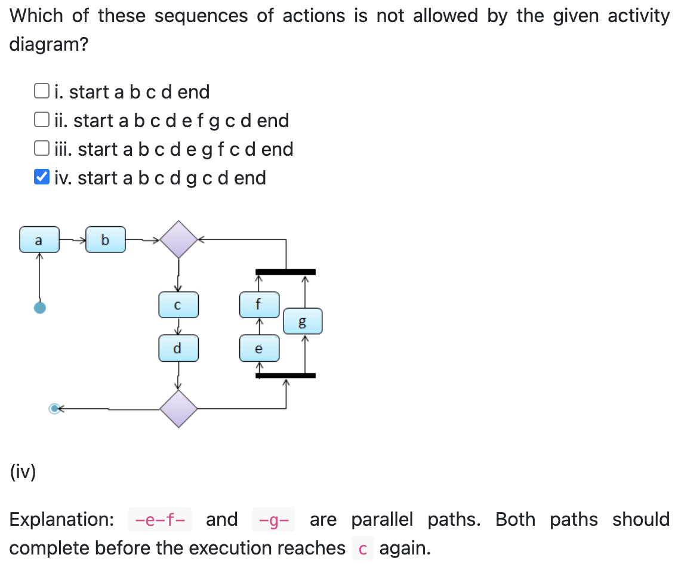

|  |  |
| --- | --- |
| Separation of concerns principle (SoC) | Higher cohesion and lower coupling. |
| Single responsibility principle (SRP) | A class should have one, and only one, reason to change. |
| Liskov substitution principle (LSP) | A subclass should not be more restrictive than the behavior specified by the superclass. 只要父类能出现的地方，子类就可以出现，**并且替换为子类也不会产生任何错误或异常**，使用者可能根本就不需要知道是父类还是子类。但反之，未要求。 |
| Open-closed principle (OCP) | A module should be open for extension but closed for modification. |
| Law of Demeter (LoD) | 对于object O中的method m, m可以调用  1. The object O itself  2. Objects passed as parameters of m  3. Objects created/instantiated in m (directly or indirectly)  4. Objects from the direct association of O |

SOLID:

Single Responsibility Principle (SRP)

Open-Closed Principle (OCP)

Liskov Substitution Principle (LSP)

Interface Segregation Principle (ISP)

Dependency Inversion Principle (DIP)

SDLC Agile (**Individuals and interactions, Working software, Customer collaboration, Responding to change**): eXtreme Programming (XP) and Scrum.

Developer Guide (**tutorials, how-to guides, explanation and technical reference**): A **top-down breadth-first explanation** is easier to understand than a bottom-up one.

Architecture Diagrams **don’t use double-headed arrows indiscriminately**.

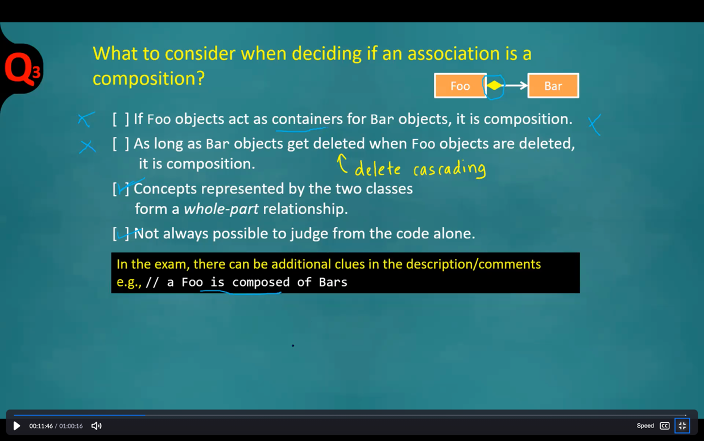

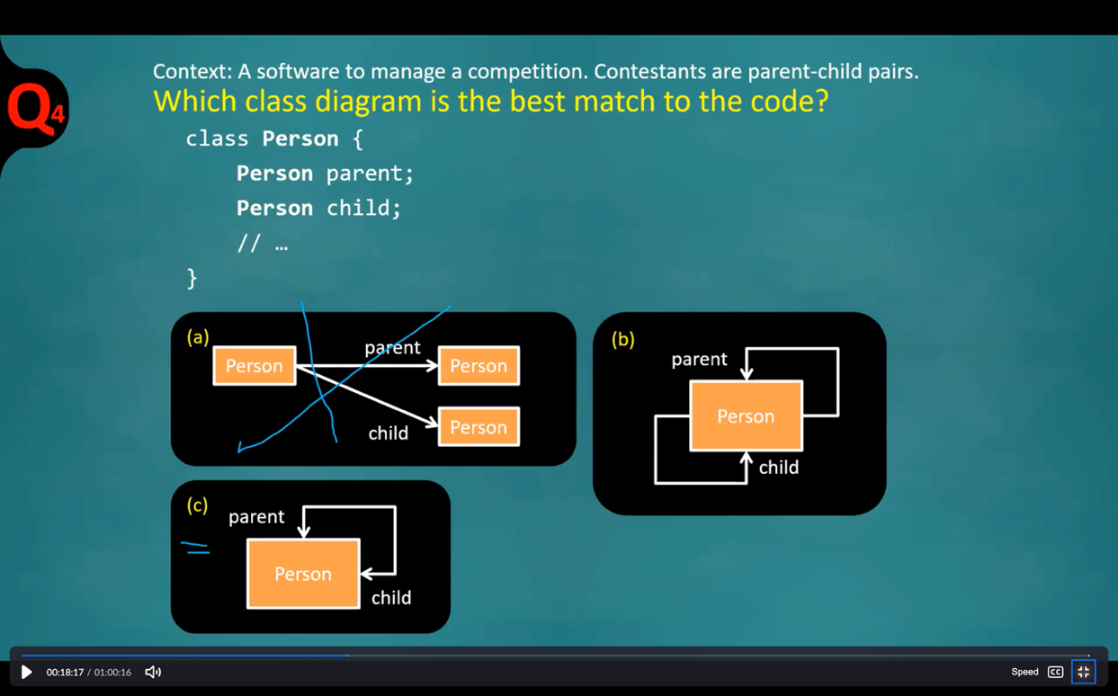

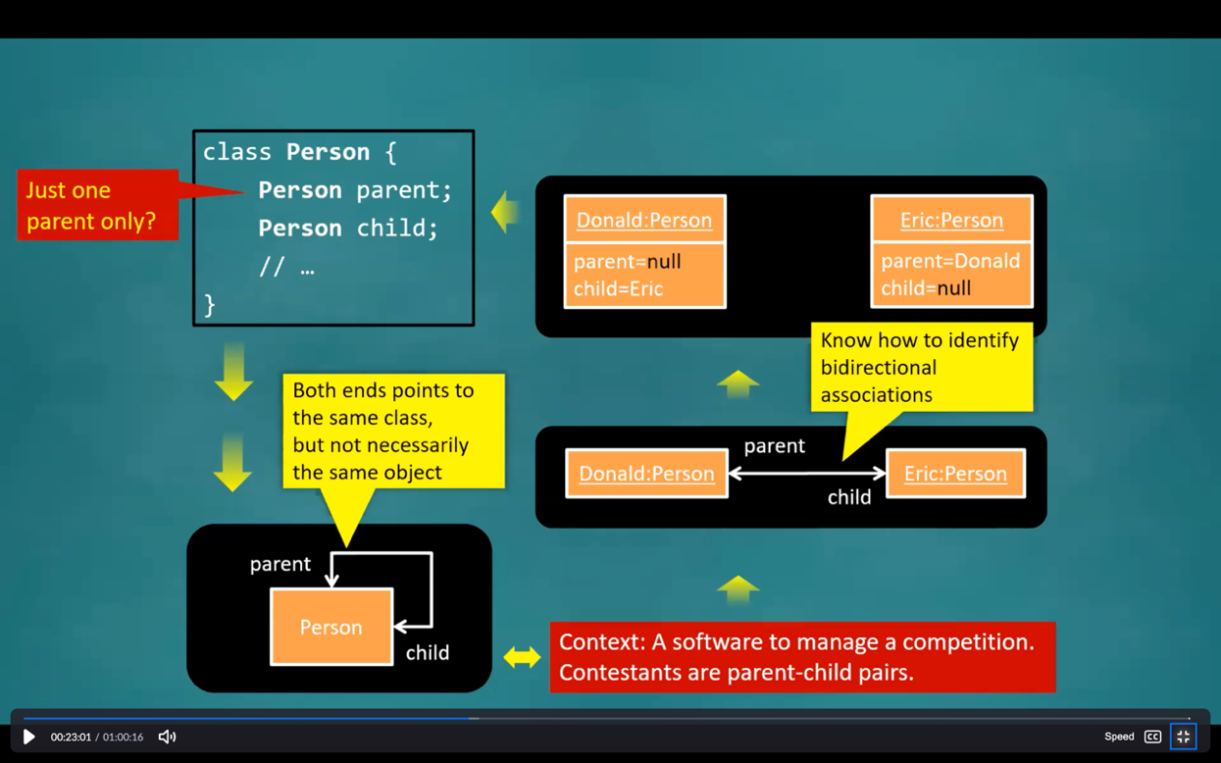

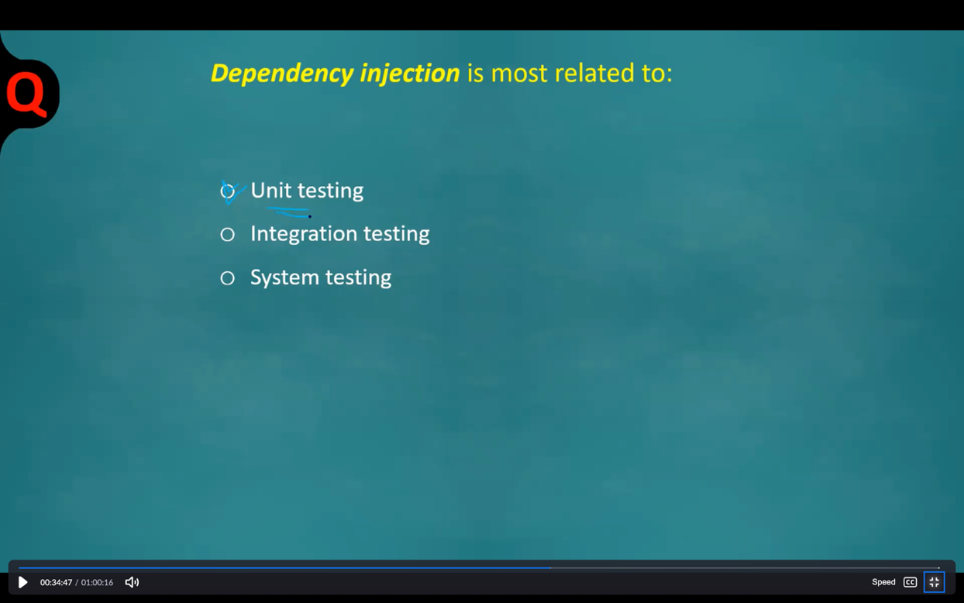

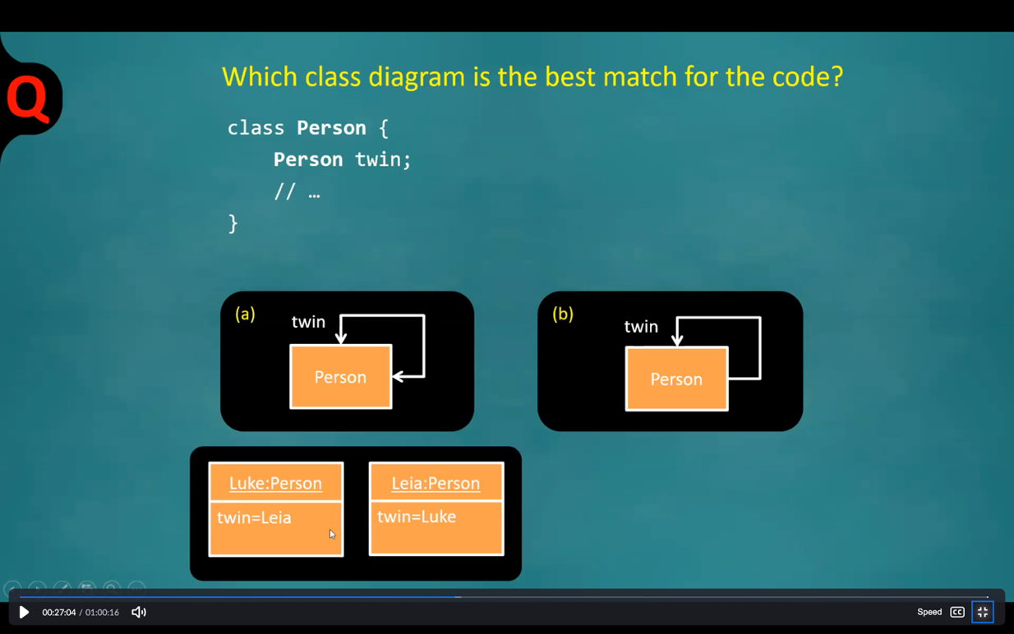

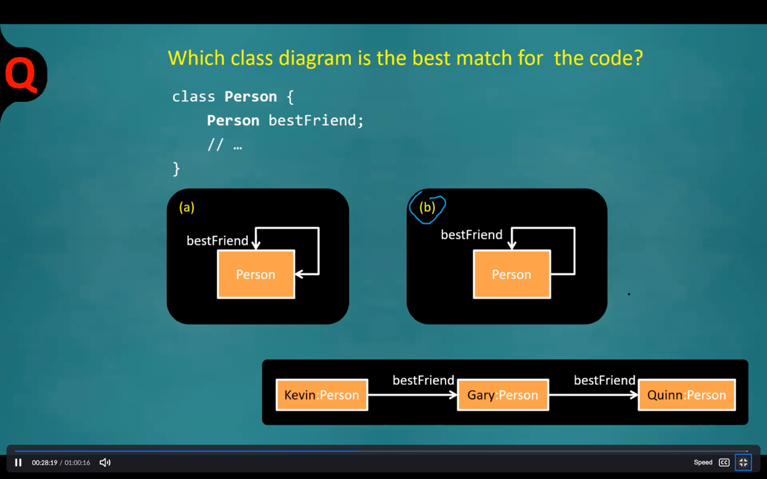

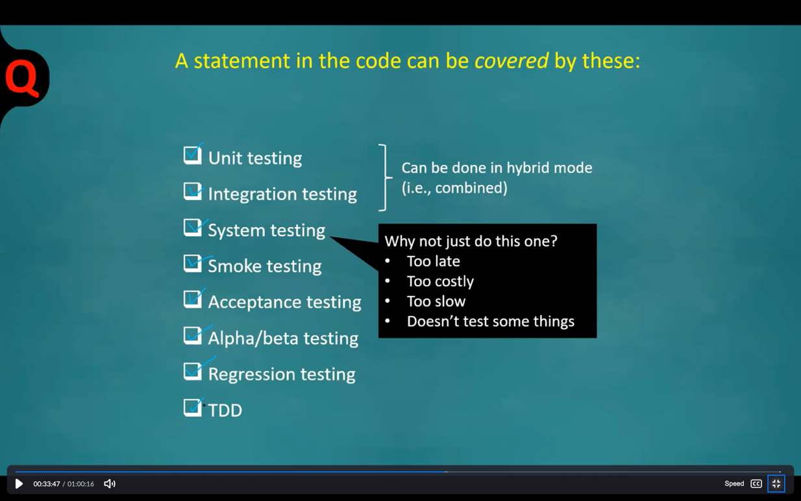

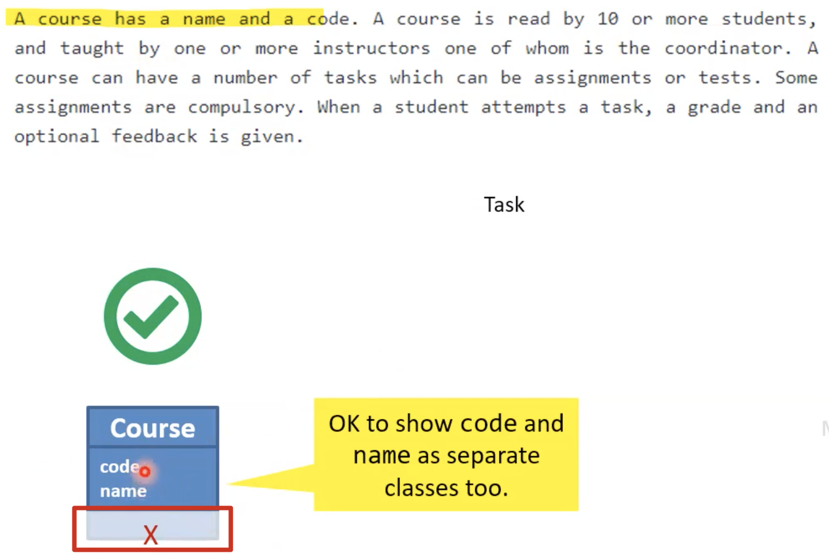 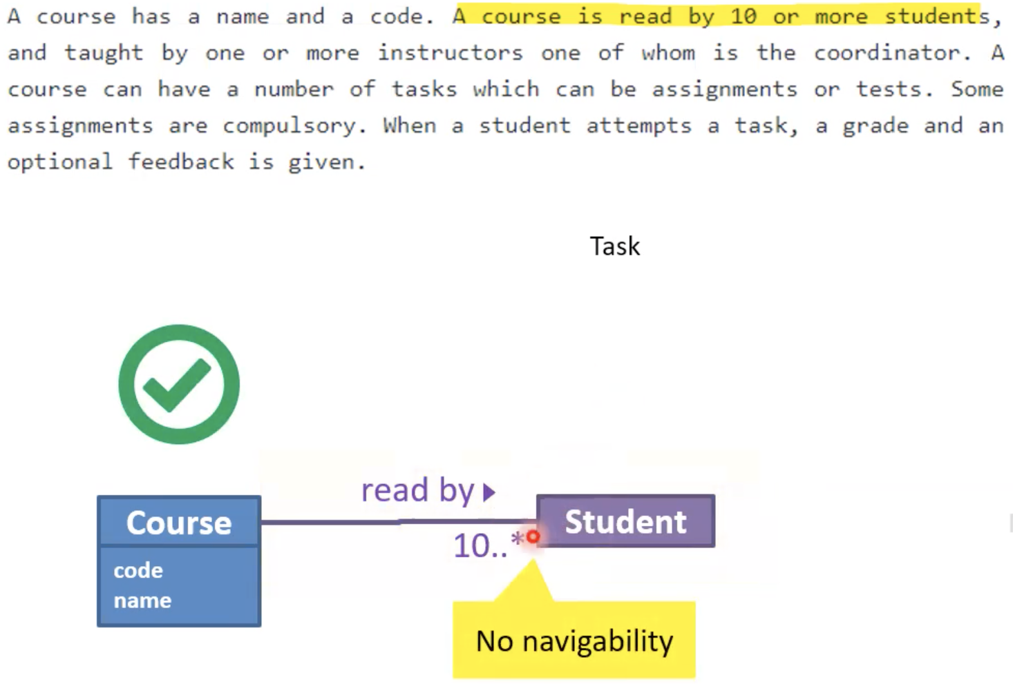

Part 2:

2. As per SRP, a **class** should have only one responsibility.

20. In the SCRUM process, iterations are called sprints.

22. A key principle of Scrum is its recognition that during a project the customers can change their minds about what they want and need (often called requirements churn), and that unpredicted challenges cannot be easily addressed in a traditional predictive or planned manner.

23. It is the Product Owner who represents the stakeholders and the business.

<https://nus-cs2103-ay2122s1.github.io/website/schedule/week9/tutorial.html>

A course has a name and a code. A course is read by 10 or more students, and **taught by one or more instructors one of whom is the coordinator.** A course can have a number of tasks which can be assignments or tests. Some assignments are compulsory. When a student attempts a task, a grade and an optional feedback is given.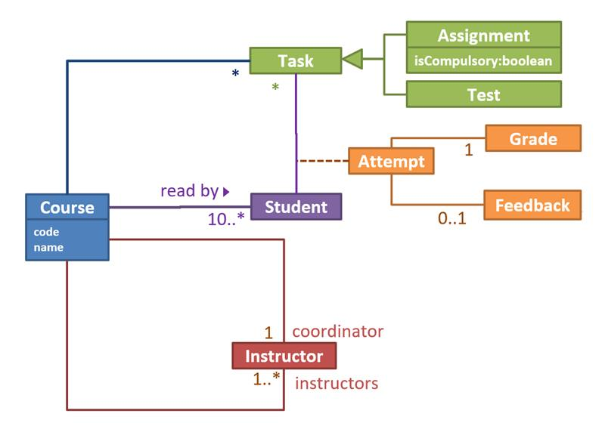

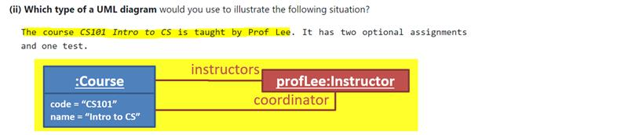

Draw an activity diagram to represent the following workflow a burger shop uses when processing an order by a customer.

* First, a cashier takes the order.
* Then, three workers start preparing the order at the same time; one prepares the drinks, one prepares the burgers, and one prepares the desserts.
* In the meantime, the customer pays for the order. If the customer has a voucher, she pays using the voucher; otherwise she pays using cash.
* After paying, the customer collects the food after all three parts of the order are ready.

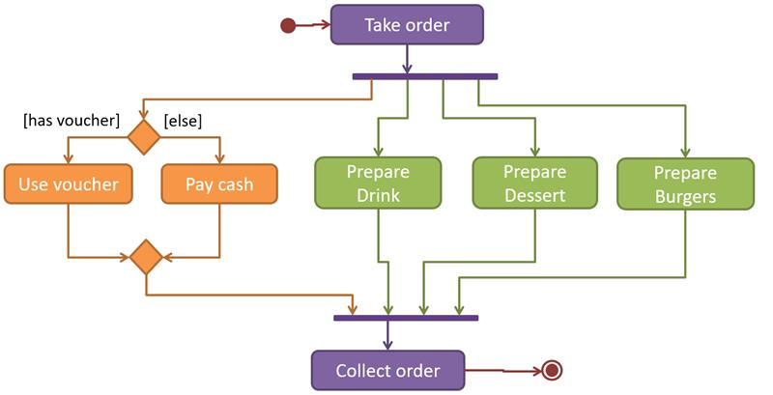

**Week 10: Design Patterns, Defensive Programming, Equivalence Partitioning, Boundary Value Analysis**

<https://nus-cs2103-ay2122s1.github.io/website/schedule/week10/topics.html>

Singleton Pattern

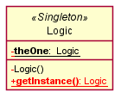

Façade Pattern

The LibraryLogic class is the Facade class.

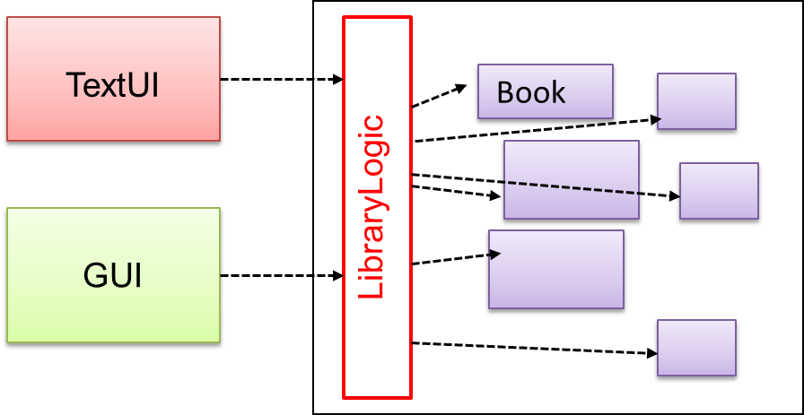

Command Pattern

The essential element of this pattern is to have a general <<Command>> object that can be passed around, stored, executed, etc without knowing the type of command (i.e. via polymorphism).

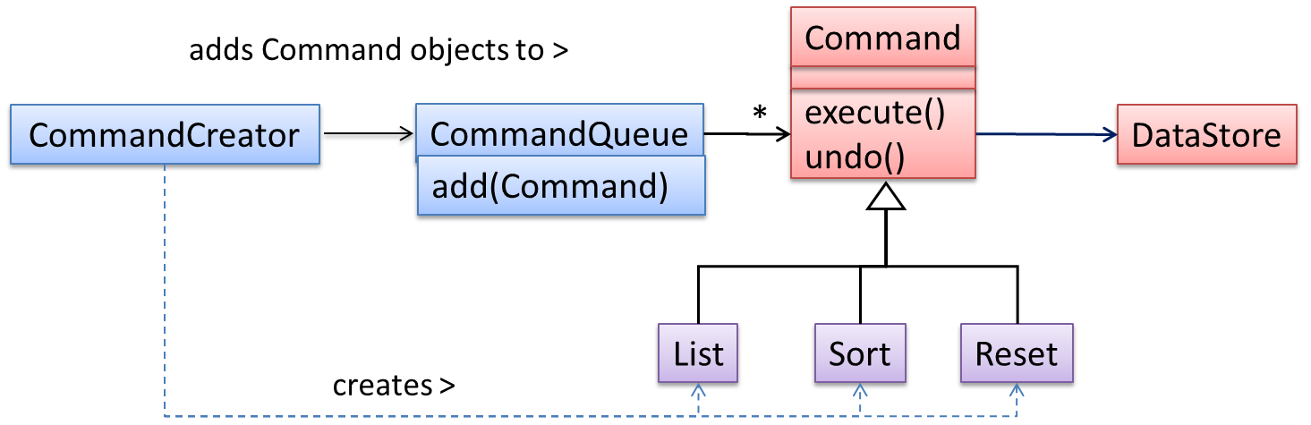

<https://www.zhihu.com/question/35451773>

|  |  |
| --- | --- |
| Black-box (aka **specification-based** or **responsibility-based**) approach | Test cases are designed exclusively based on the SUT’s specified external behavior, i.e. Acceptance Testing |
| White-box (aka glass-box or structured or implementation-based) approach | Test cases are designed based on what is known about the SUT’s implementation, i.e. the code |
| Gray-box approach |  |

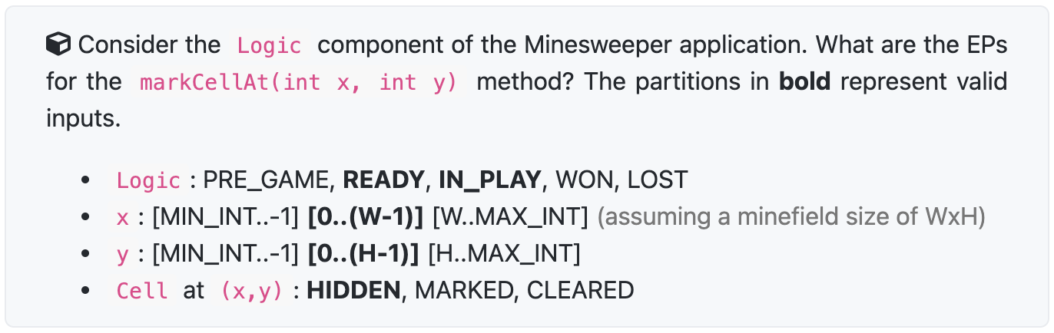

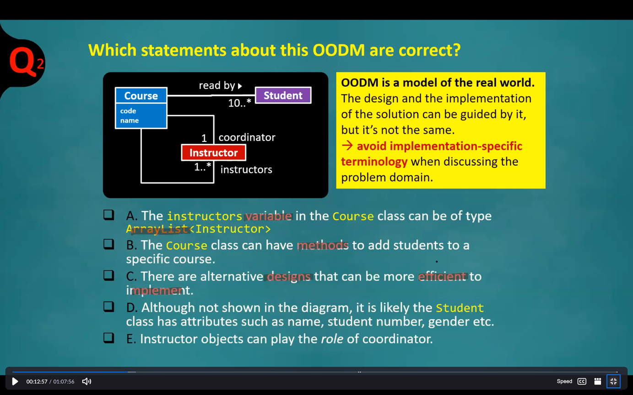

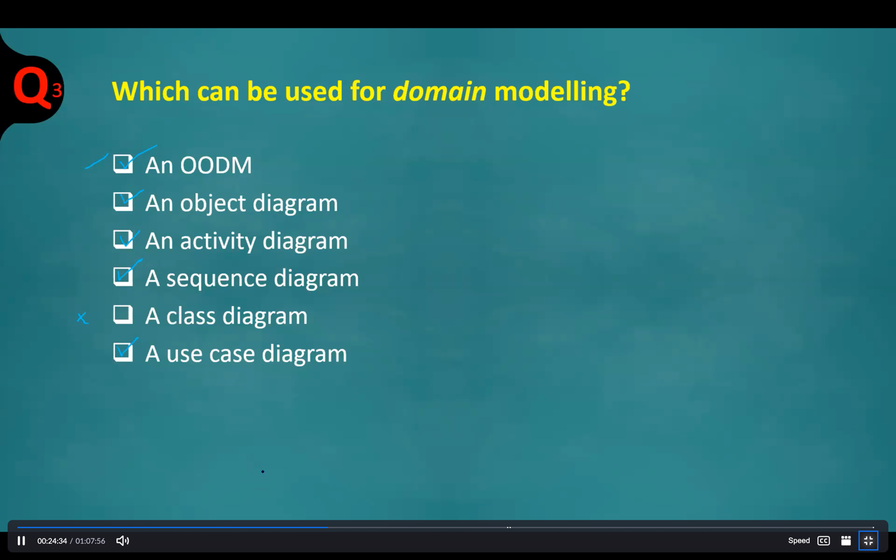

29. Test cases set X has 40 test cases and finds 10 defects in a SUT, Test cases set Y has 20 test cases and finds 10 defects in the same SUT. --> **They are equally effective (finds the same number of defects)** but Y is more efficient as it can find the same number of defects using fewer test cases.

32. More test cases is not always better. We need to consider cost of testing as well.

38. When deciding EPs of a method of an object, the state of the target object should be considered too.

**Week 11: Design Patterns(MVC, Observer Pattern), Architectural Styles, QA Techniques, Reuse**

<https://nus-cs2103-ay2122s1.github.io/website/schedule/week11/topics.html>

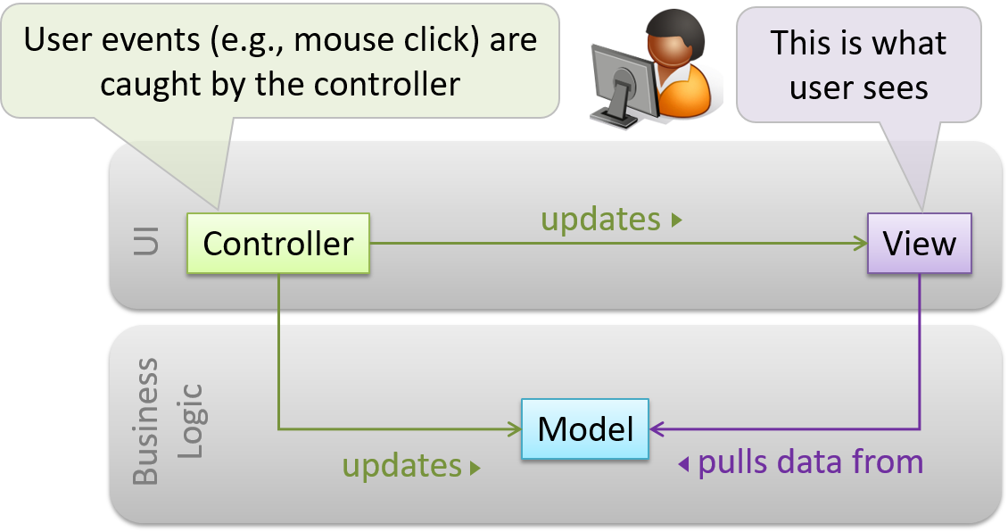

**模型View不用依赖Data, View是独立的**

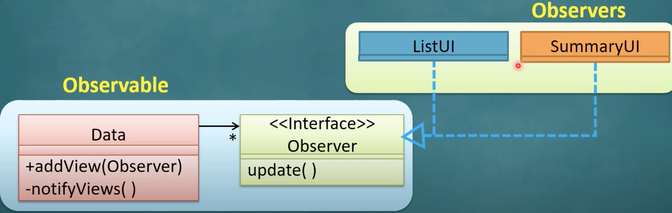

Data data = new Data();

ListUI listUI = new ListUI();

SummaryUI summaryUI = new SummaryUI();

// 注意listUI和summaryUI都implement了Observer接口，因此可以执行addView

data.addView(listUI);

data.addView(summaryUI);

public void addView(Observer o) {

observerList.add(o);

}

// 注意update这里用了polymorphism，ListUI和SummaryUI都分别override了update

public void notifyViews() {

for (Observer o: observerList) {

o.update();

}

}

Software architectures follow various high-level styles (aka architectural patterns)

|  |  |
| --- | --- |
| n-Tier Style | Operating systems and network communication software often use n-tier style. |
| Client-Server Style | The online game and the web application use the client-server style. |
| Event-driven Style | When the “button clicked” event occurs in a **GUI**, that event can be transmitted to components that are interested in reacting to that event. |
| Transaction Processing Style | In this example from a banking system, transactions are generated by the terminals used by tellers, which are then sent to a central dispatching unit, which in turn dispatches the transactions to various other units to execute. |
| Service-Oriented Style (SOA) | SOA builds applications by combining functionalities packaged as programmatically accessible services. |

**Effective有效(得到较好的效果, 与总量无关) and Efficient高效(短时间内得到效果)**

All combinations strategy: 测试所有组合

At least once strategy: 每个输入至少出现一次

All pairs strategy: 任意选取两个输入，最终的测试用例必须包含这两个输入的所有组合

还可以有其它的测试策略

**Heuristic启发式**

正向测试用例(Positive Test Case): 系统支持的输入

反向测试用例(Negative test Case): 系统不支持的输入

每个valid有效的输入至少有一次出现在一个**正向测试用例**, 注意关键词: **至少有一次, valid, 正向测试用例**

在一个测试用例不超过一个invalid无效的输入, 注意关键词: **不超过一个, invalid**

注意: 若输入存在其它的依赖关系, 则需要额外的测试用例测试

Quality Assurance = Validation + Verification

Validation(确认): are you building the right system i.e., are the requirements correct?

Verification(验证): are you building the system right i.e., are the requirements implemented correctly?

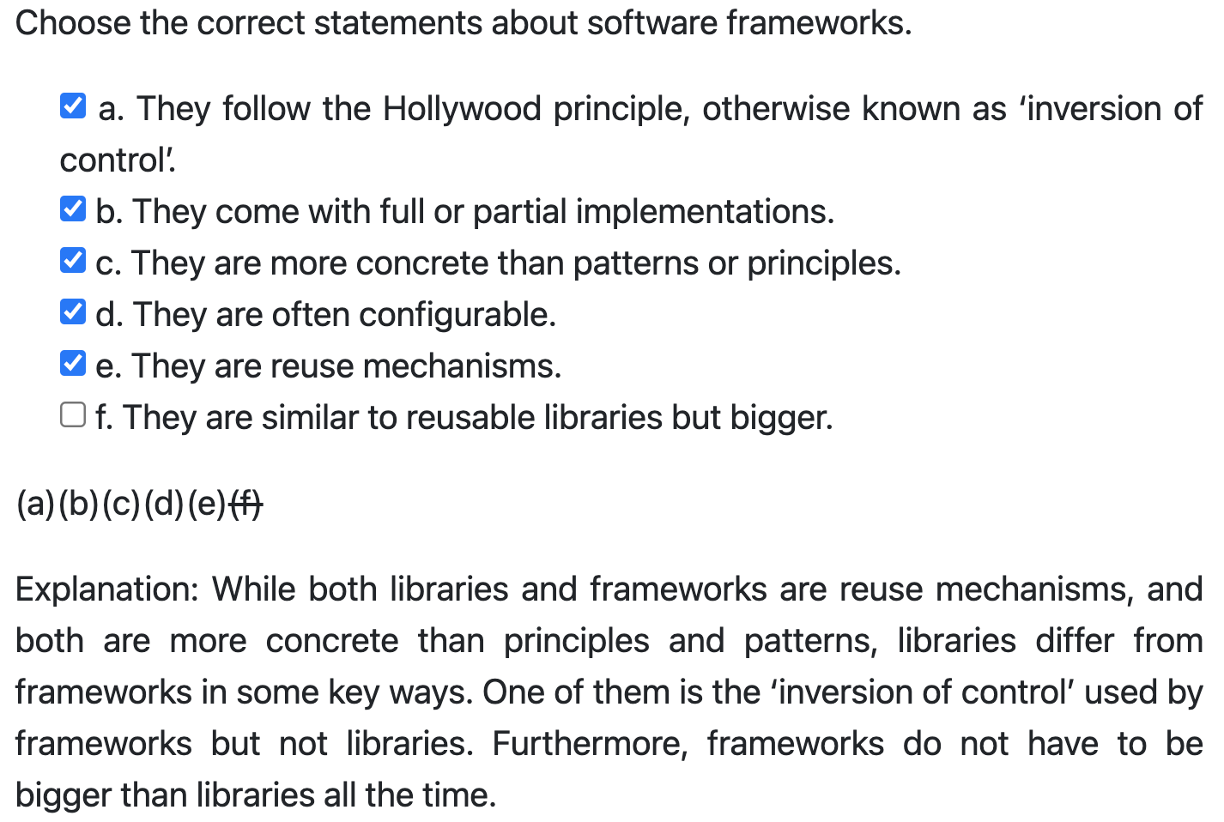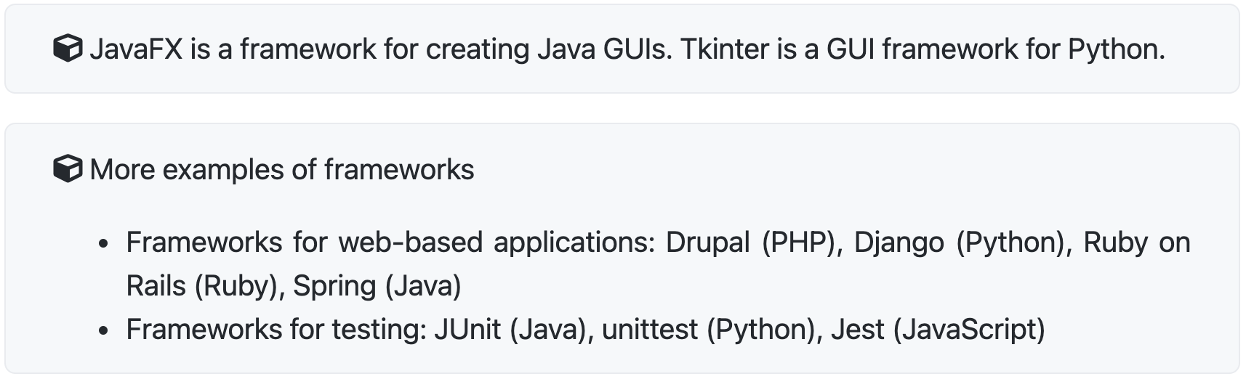

**我的代码调用library, 而framework调用我的代码(Hollywood principle)**

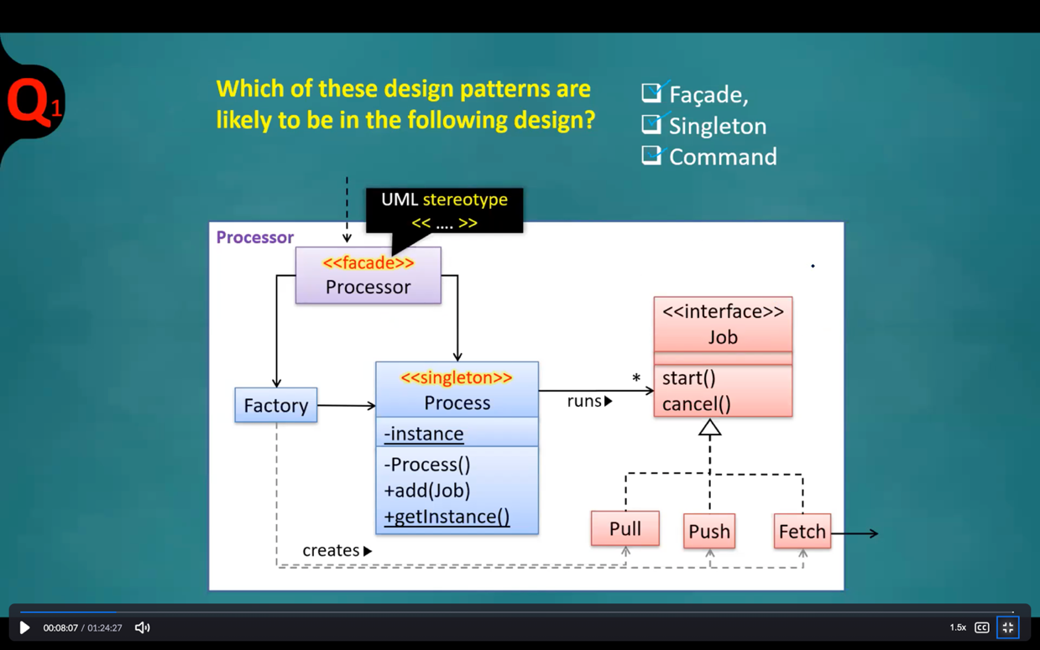

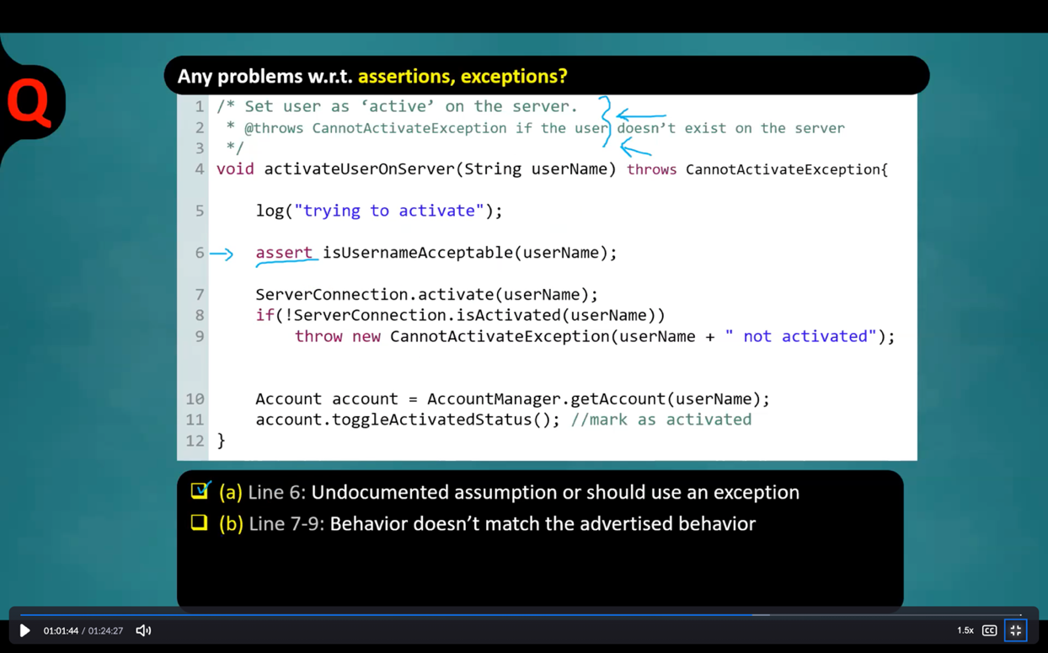

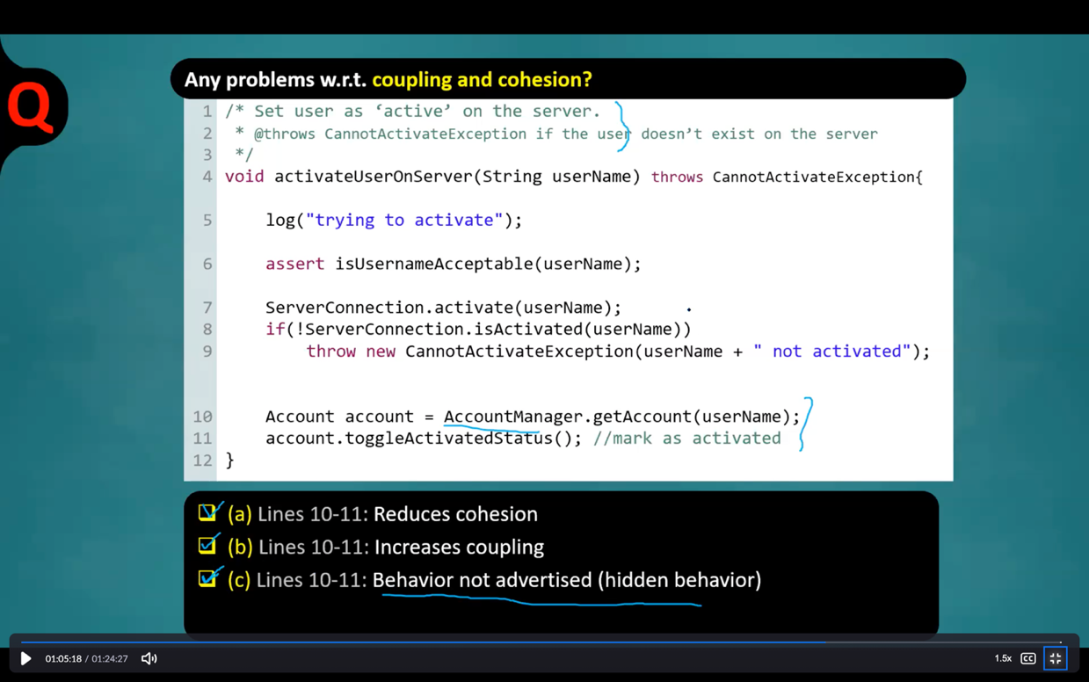

29. Testing all possible combinations **is effective but not efficient**.

31. Formal methods, when compared to testing, is more expensive in general.

33. Whether something belongs under validation or verification is not that important. What is more important is both are done, instead of limiting to verification.

40. A platform comes with a runtime. That is exactly what distinguishes a platform from a library/framework.

41. Libraries are meant to be used ‘as is’ while frameworks are meant to be customized/extended.

